**LAMPIRAN**

Lampiran 1. Lembar Penjelasan Penelitian

**PENJELASAN PENELITIAN**

Saya yang bertanda tangan di bawah ini:

|  |  |
| --- | --- |
| Nama peneliti | : Renza Selviana |
| NPM | : 113063C119041 |
| Judul Skripsi | : Gambaran Pengetahuan Mahasiswa Sarjana Keperawatan dan Fisioterapi Regular Terkait Pelecehan Seksual Di Stikes Suaka Insan Banjarmasin |

Mohon kesediaan Mahasiswa untuk menjadi responden dalam penelitian saya yang berjudul **“Gambaran Pengetahuan Mahasiswa Sarjana Keperawatan dan Fisioterapi Regular Terkait Pelecehan Seksual Di Stikes Suaka Insan Banjarmasin”**. Berikut ini saya jelaskan hal-hal penting terkait pengambilan data:

1. Tujuan penelitian ini untuk untuk mengetahui Gambaran Pengetahuan Mahasiswa Sarjana Keperawatan dan Fisioterapi Regular Terkait Pelecehan Seksual Di Stikes Suaka Insan Banjarmasin.
2. Manfaat dari penelitian ini dapat membuka paradigma berfikir dalam mendalami permasalahan kekerasan seksual terhadap Mahasiswa yang banyak terjadi selama ini dan semakin marak, serta menjadi bahan kajian dan memberi sumbangan pemikiran dan informasi dalam upaya pencegahan kekerasan seksual terhadap Mahasiswa.
3. Penelitian ini tidak akan memengaruhi atau merugikan fisik, psikis, pekerjaan, dan karir Mahasiswa karena tidak ada perlakuan kepada Mahasiswa. Penelitian ini mengambil data dengan cara prosedur pengisian kuesioner.
4. Penelitian ini bersifat sukarela dan tidak ada paksaan untuk menjadi partisipan.
5. Saya menghargai hak Mahasiswa untuk menjadi partisipan penelitian ini. Saya juga menghargai hak Mahasiswa apabila tidak bersedia menjadi partisipan, saya menjamin tidak ada konsekuensi atau sanksi terkait penolakan tersebut.
6. Saya menghargai hak Mahasiswa jika sewaktu-waktu ingin mengundurkan diri dari penelitian ini dan saya menjamin tidak ada konsekuensi atau sanksi terkait pengunduran diri tersebut.
7. Pengambilan data dilakukan menggunakan prosedur pengisian kuesioner. Lama waktu pengisian kurang lebih 10-15 menit
8. Saya akan memberi penjelasan secara lengkap mengenai isi dari kuesioner. Mahasiswa diberi kesempatan untuk menanyakan hal-hal yang belum dipahami.
9. Informasi yang saya dapatkan dari Mahasiswa akan dirahasiakan dan hanya digunakan untuk kebutuhan penelitian
10. Mahasiswa yang bersedia berpartisipasi dalam penelitian ini diminta untuk menandatangani formulir persetujuan sebagai responden penelitian yang disediakan oleh peneliti.
11. Pelaporan hasil penelitian ini hanya akan menggunakan kode partisipan dan bukan nama asli atau inisial.
12. Setelah menyelesaikan proses partisipan akan mendapatkan souvenir sebagai tanda terima kasih sudah berpartisipasi dalam penelitian.
13. Jika terdapat hal-hal yang belum dimengerti dapat menghubungi peneliti di kontak: 0821 5543 3972 atau via email: [renzaselviana852553@gmail.com](mailto:renzaselviana852553@gmail.com)

Demikian penjelasan penelitian ini dibuat. Atas kesediaan dan kerjasama diucapkan terima kasih.

Banjarmasin, 27 Januari 2023

Peneliti

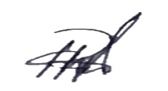

**Renza Selviana**

**NIM: 113063C119041**

Lampiran 2. Uji Etik

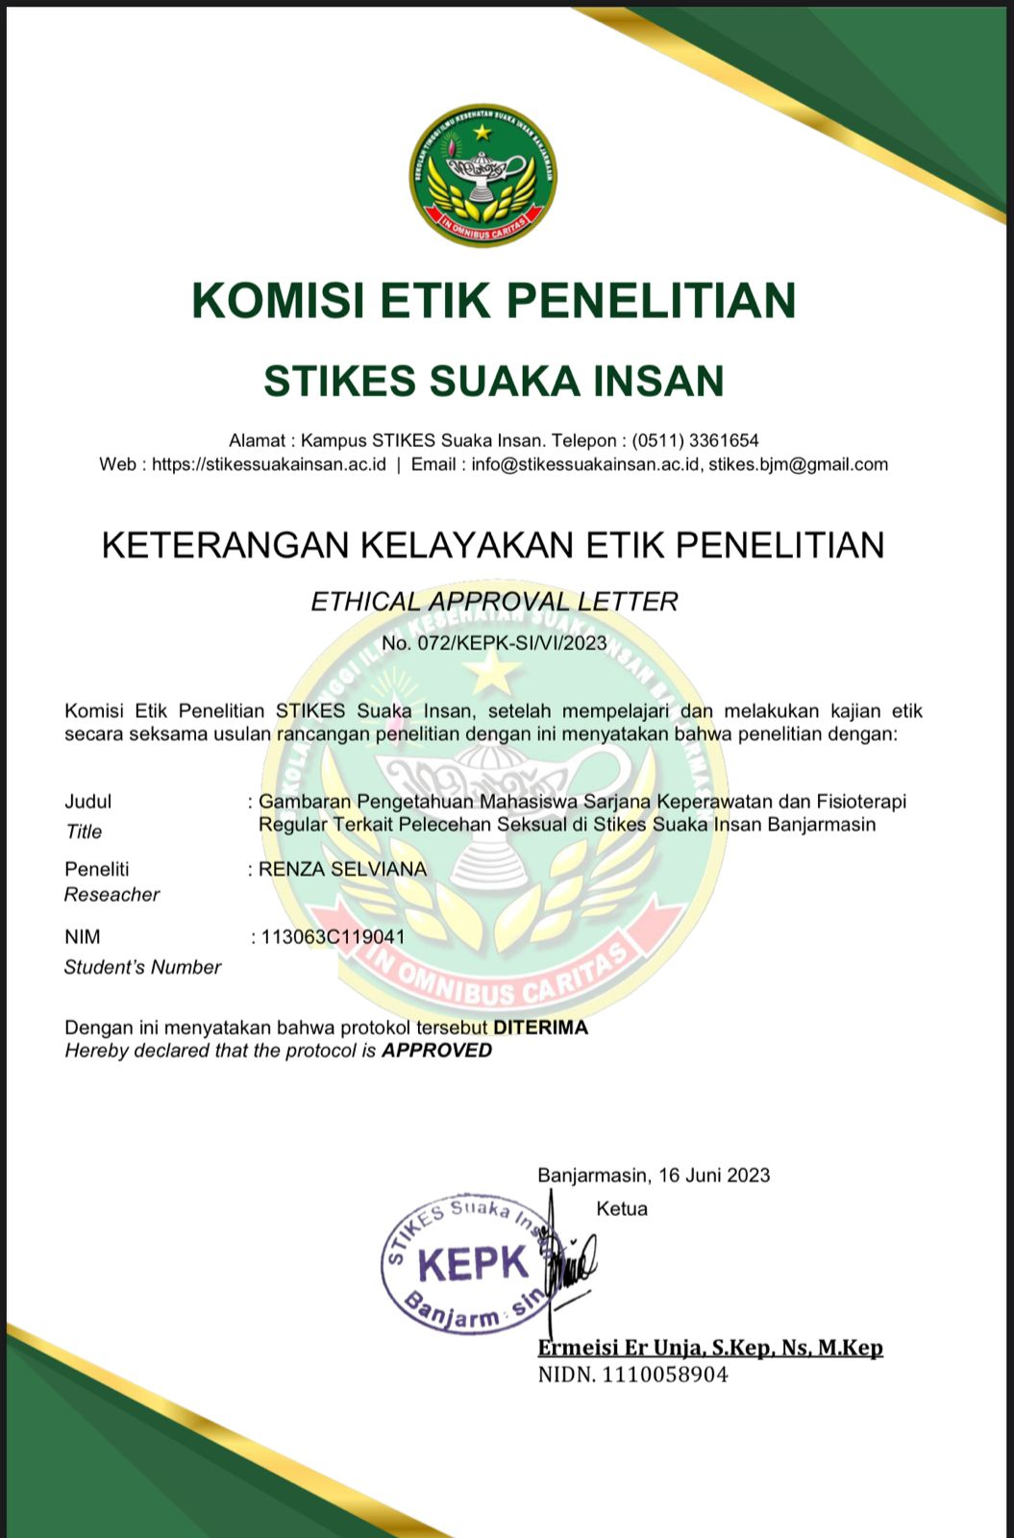

Lampiran 3. Surat Izin Studi Pendahuluan

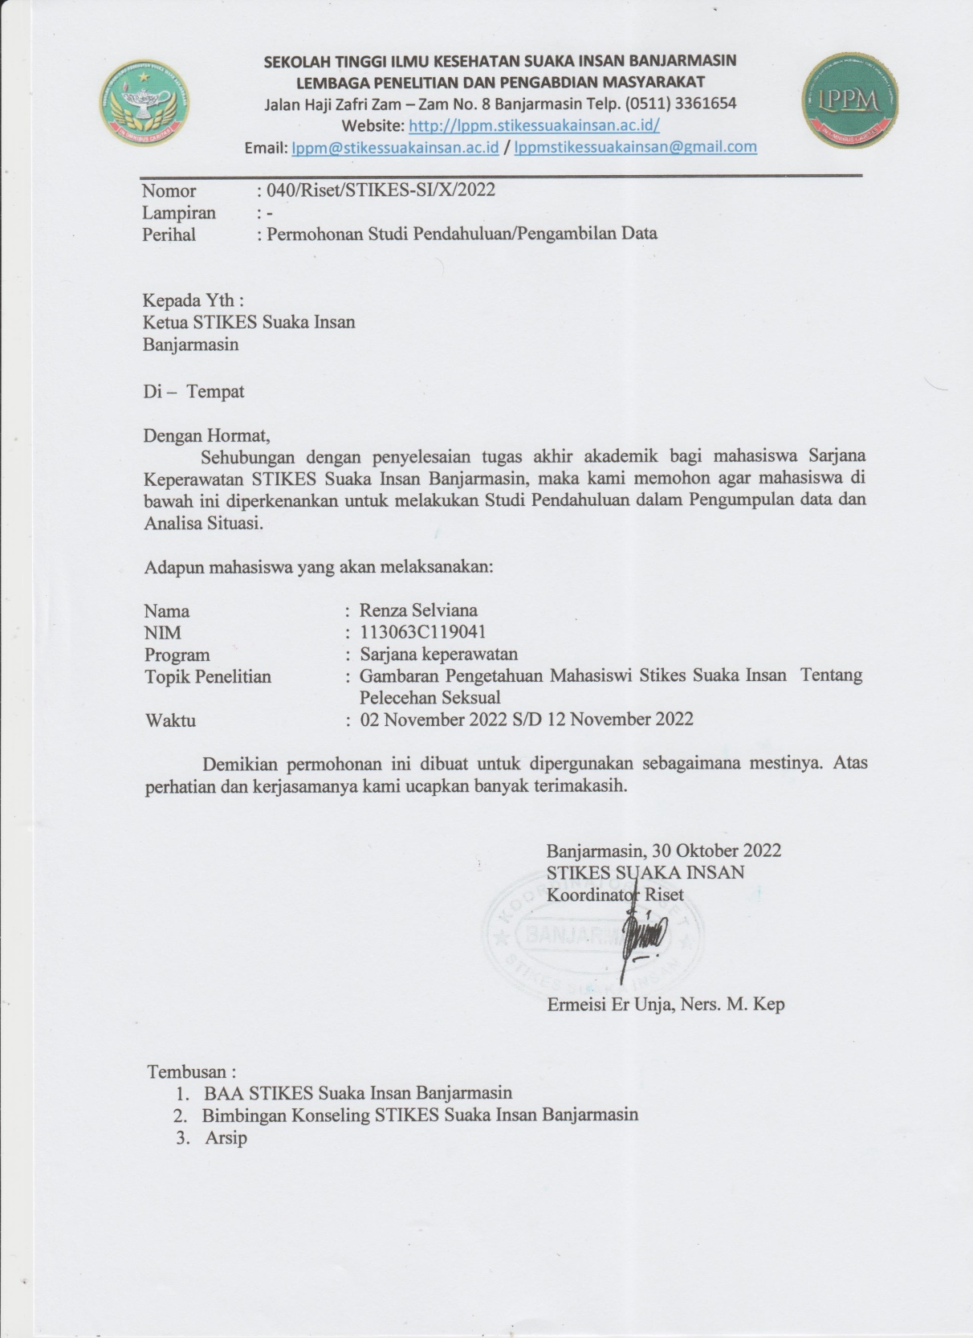

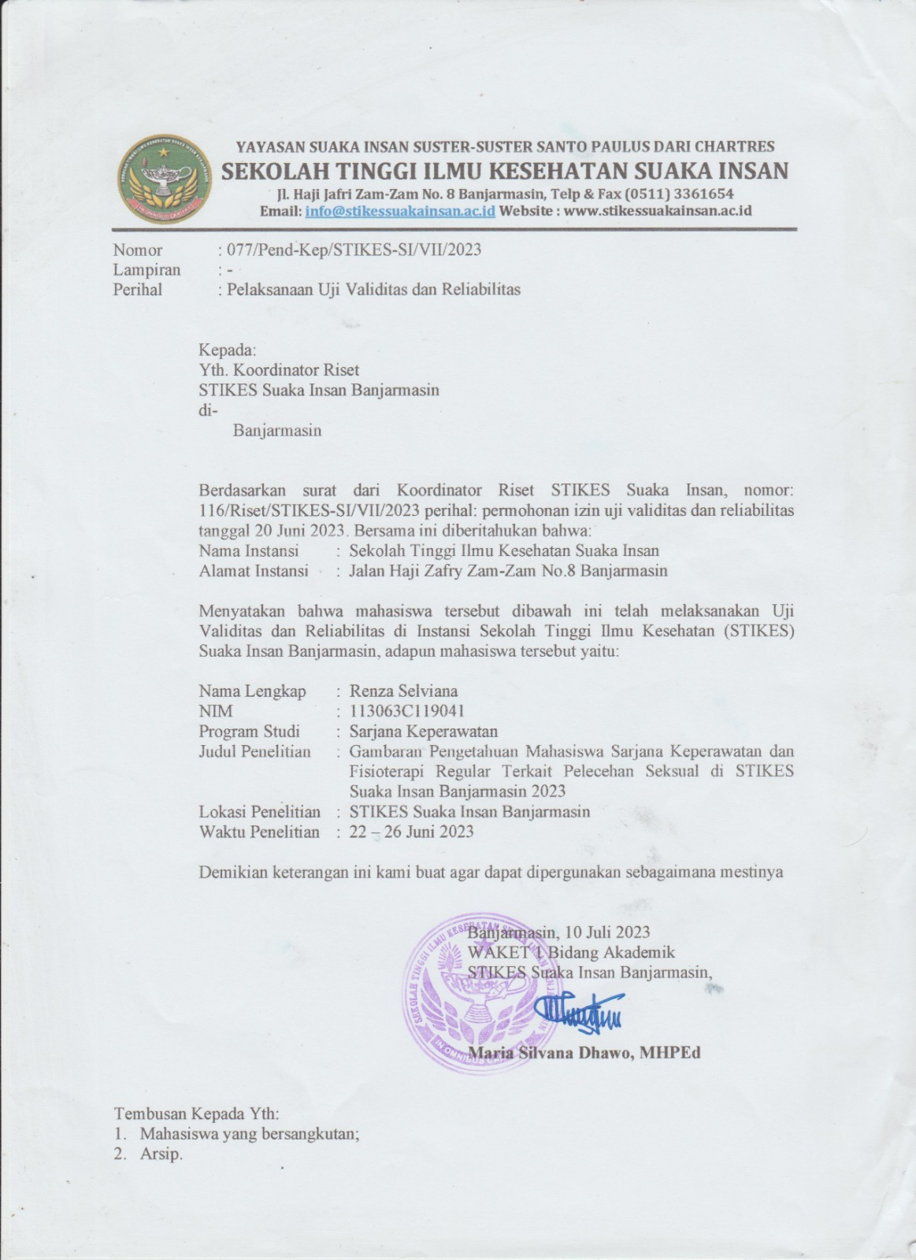

Lampiran 4. Surat Balasan Studi Pendahuluan

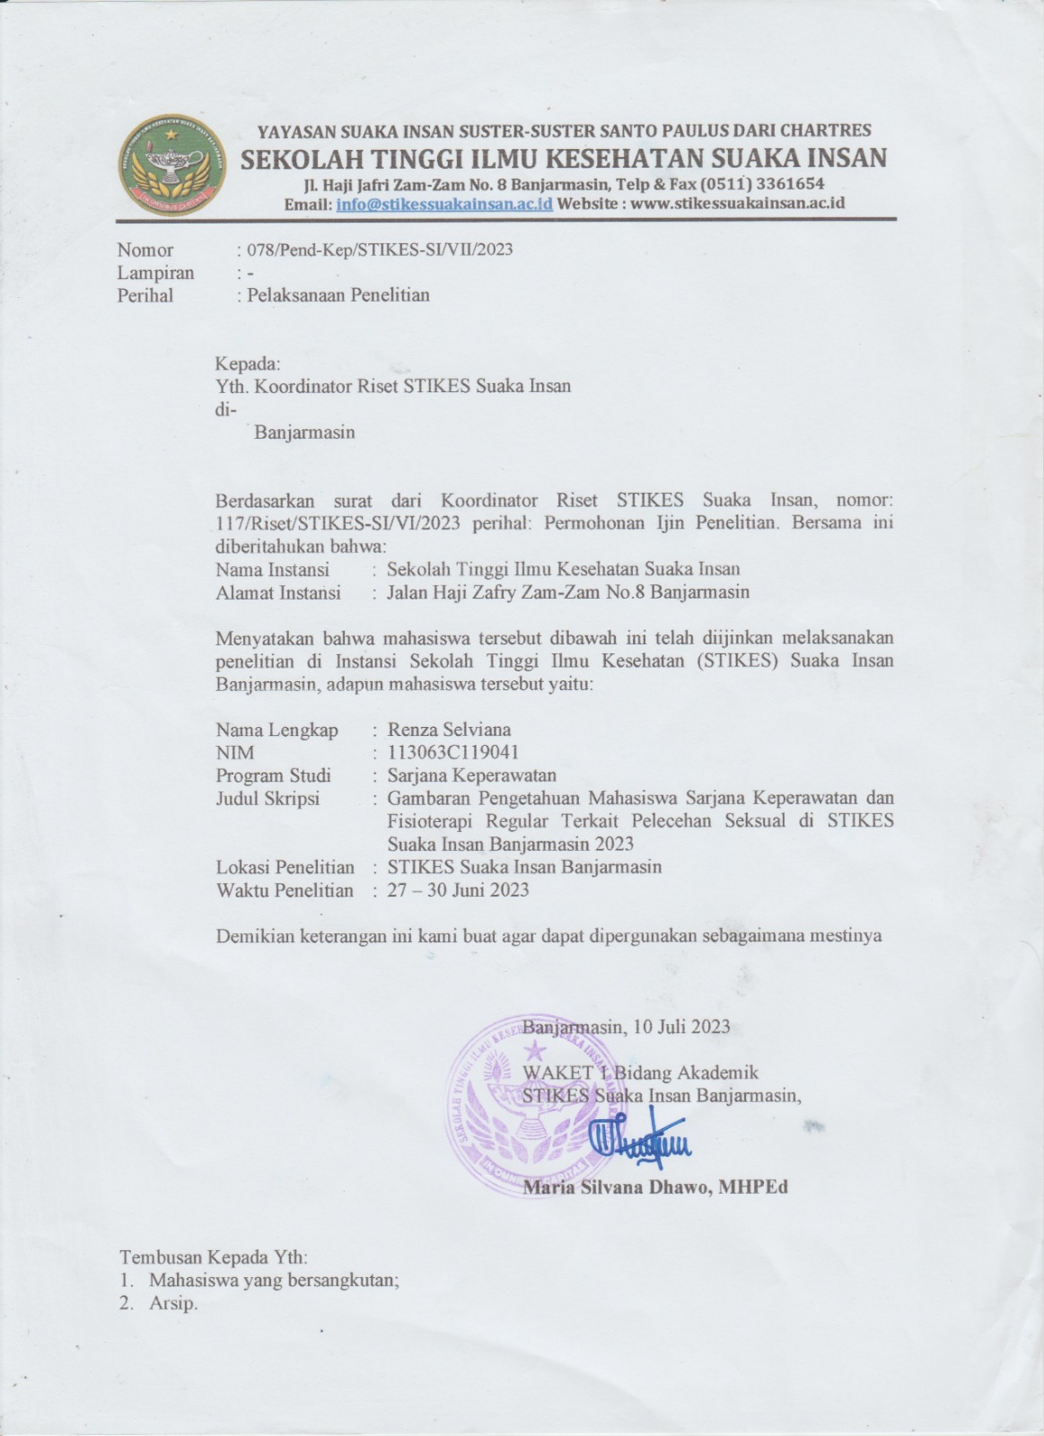

Lampiran 5. Lembar Persetujuan Sebagai Responden

**LEMBAR PERSETUJUAN SEBAGAI RESPONDEN**

**Inisial:**

…………..

Saya yang bertanda tangan di bawah ini:

Nama

Kaprodi

Semester

Telah mendapatkan penjelasan tentang prosedur, tujuan, serta manfaat penelitian tentang: “Gambaran Pengetahuan Mahasiswa Sarjana Keperawatan dan Fisioterapi Regular Terkait Pelecehan Seksual Di Stikes Suaka Insan Banjarmasin, atas nama: Renza Selviana

NIM. 113063C119041

Saya memahami sepenuhnya dan memberikan persetujuan untuk menjadi partisipan dalam penelitian ini. Saya memahami hak dan kewajiban saya sebagai partisipan, tidak ada risiko fisik maupun pisikis di dalamnya karena telah diinformasikan kerahasiaan dan manfaat penelitian ini bagi pelayanan keperawatan secara umum. Persetujuan ini saya berikan dengan penuh kesadaran dan tanpa unsur paksaan dari pihak mana pun.

Banjarmasin, Januari 2023

Responden

(…………………………)

Lampiran 6. Lembar Kuesioner

**LEMBAR KUESIONER**

**Instruksi**

Berikut ini terdapat sejumlah pernyataan-pernyataan. Pernyataan tersebut membantu untuk mengenali perasaan sebagaimana Pengetahuan Mahasiswa Terkait Pelecehan Seksual. Bacalah setiap pernyataan dengan seksama, lalu pilihlah salah satu dari jawaban yang tersedia. Jawaban diberikan dengan tanda centang (√) pada jawaban yang di pilih. Apabila ingin mengubah jawaban, coretlah jawaban yang salah tersebut kemudian pilihlah kembali jawaban yang saudara anggap paling sesuai.

Kode Partisipan :…………………………..

**Pengetahuan Mahasiswa Mengenai Bentuk Tindakan Pelecehan Seksual**

|  |  |  |  |
| --- | --- | --- | --- |
| **No** | **Bentuk-bentuk perilaku** | **Apakah merupakan pelecehan seksual?** | |
| **Ya** | **Tidak** |
| 1 | Tatapan yang tidak diinginkan secara sensual ke wilayah payudara perempuan sehingga menimbulkan perasaan tidak nyaman bagi pihak sasaran |  |  |
| 2 | Mengarahkan pembicaraan cabul/bernuansa seksual kepada seseorang atau kelompok orang sehingga menimbulkan keresahan atau ketidaknyamanan |  |  |
| 3 | Tatapan yang tidak diinginkan secara sensual ke wilayah kelamin (selangkangan) perempuan |  |  |
| 4 | Tatapan yang tidak diinginkan bernuansa sensual ke wilayah kelamin (selangkangan) pria |  |  |
| 5 | Mengelus tanpa ijin |  |  |
| 6 | Mengirim seseorang surat, pesan atau gambar manual atau elektronik bernuansa seksual yang tidak diinginkan. |  |  |
| 7 | Memaksa seseorang menyaksikan tanyangan pornografi |  |  |
| 8 | Menunjukkan simbol atau mengajak hubungan seks terhadap seseorang |  |  |
| 9 | Menyuap bawahan (karyawan, murid) agar mau melakukan aktivitas seksual dengan imbalan yang berhubungan dengan perkerjaan atau studi |  |  |
| 10 | Upaya terus menerus meminta seseorang membangun hubungan romantic walaupun telah ditolak sehingga menimbulkan keresahan |  |  |
| 11 | Melakukan masturbasi di hadapan seseorang atau sekelompok orang |  |  |
| 12 | Memberi komentar terhadap seseorang dengan istilah seksual yang merendahkan atau menghina |  |  |

Lampiran 7. Perhitungan Uji Validitas dan Reliabilitas

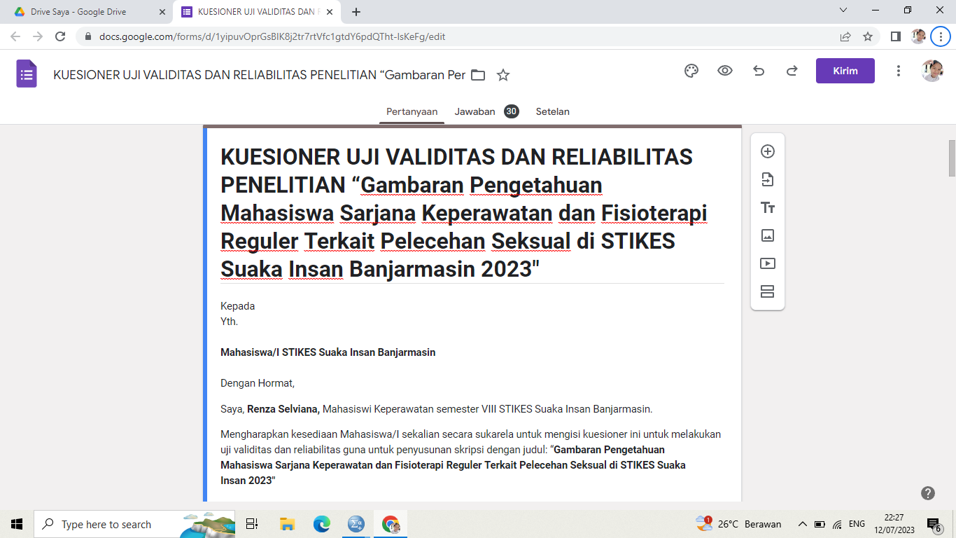

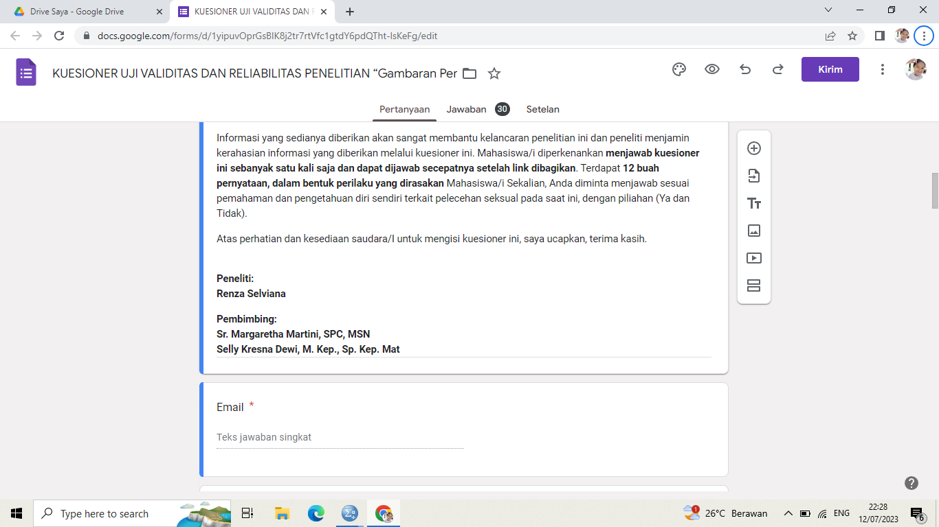

|  |  |  |  |  |  |  |  |  |  |  |  |  |  |  |
| --- | --- | --- | --- | --- | --- | --- | --- | --- | --- | --- | --- | --- | --- | --- |
| **UJI VALIDITAS DAN RELIABELITAS** | | | | | | | | | | | | | | |
| **GAMBARAN PENGETAHUAN MAHASISWA SARJANA KEPERAWATAN DAN FISIOTERAPI REGULER TERKAIT PELECAHAN SEKSUAL** | | | | | | | | | | | | | | |
| **DI STIKES SUAKA INSAN BANJARMASIN TAHUN 2023** | | | | | | | | | | | | | | |
|  |  |  |  |  |  |  |  |  |  |  |  |  |  |  |
| **VARIABEL** | | | | | | | | | | | | | | |
| **R** | **Mahasiswa** | **P1** | **P2** | **P3** | **P4** | **P5** | **P6** | **P7** | **P8** | **P9** | **P10** | **P11** | **P12** | **TOTAL** |
| R1 | 1 | 0 | 0 | 0 | 0 | 0 | 0 | 0 | 0 | 0 | 0 | 0 | 0 | 0 |
| R2 | 1 | 1 | 0 | 0 | 0 | 0 | 0 | 0 | 0 | 0 | 0 | 0 | 0 | 1 |
| R3 | 1 | 0 | 0 | 0 | 0 | 0 | 0 | 0 | 0 | 0 | 0 | 0 | 0 | 0 |
| R4 | 1 | 1 | 1 | 1 | 1 | 1 | 1 | 1 | 1 | 1 | 1 | 1 | 1 | 12 |
| R5 | 1 | 1 | 1 | 1 | 1 | 1 | 1 | 1 | 1 | 1 | 1 | 1 | 1 | 12 |
| R6 | 1 | 0 | 0 | 0 | 0 | 0 | 0 | 0 | 0 | 0 | 0 | 0 | 0 | 0 |
| R7 | 1 | 0 | 0 | 0 | 0 | 0 | 0 | 0 | 0 | 0 | 0 | 0 | 0 | 0 |
| R8 | 1 | 0 | 0 | 0 | 0 | 0 | 0 | 0 | 0 | 0 | 0 | 0 | 0 | 0 |
| R9 | 1 | 0 | 0 | 0 | 0 | 0 | 0 | 0 | 0 | 0 | 0 | 0 | 0 | 0 |
| R10 | 1 | 0 | 0 | 0 | 0 | 1 | 1 | 1 | 1 | 1 | 1 | 1 | 0 | 7 |
| R11 | 1 | 0 | 0 | 1 | 0 | 0 | 0 | 0 | 0 | 0 | 0 | 0 | 0 | 1 |
| R12 | 1 | 0 | 1 | 1 | 1 | 1 | 1 | 1 | 1 | 1 | 1 | 1 | 1 | 11 |
| R13 | 1 | 0 | 0 | 0 | 0 | 0 | 0 | 0 | 0 | 0 | 0 | 0 | 0 | 0 |
| R14 | 1 | 0 | 0 | 0 | 0 | 1 | 1 | 1 | 1 | 1 | 1 | 1 | 0 | 7 |
| R15 | 1 | 0 | 0 | 1 | 1 | 1 | 1 | 1 | 1 | 1 | 1 | 1 | 1 | 10 |
| R16 | 1 | 0 | 0 | 0 | 0 | 1 | 0 | 1 | 1 | 1 | 1 | 1 | 1 | 7 |
| R17 | 1 | 1 | 1 | 1 | 1 | 1 | 1 | 1 | 1 | 1 | 1 | 1 | 1 | 12 |
| R18 | 1 | 0 | 0 | 0 | 0 | 0 | 0 | 0 | 0 | 0 | 0 | 0 | 0 | 0 |
| R19 | 1 | 1 | 1 | 1 | 1 | 1 | 1 | 1 | 1 | 1 | 1 | 1 | 0 | 11 |
| R20 | 1 | 0 | 0 | 1 | 1 | 1 | 0 | 1 | 1 | 0 | 1 | 1 | 1 | 8 |
| R21 | 1 | 0 | 0 | 0 | 1 | 1 | 1 | 1 | 1 | 1 | 1 | 1 | 1 | 9 |
| R22 | 1 | 0 | 0 | 0 | 0 | 0 | 0 | 0 | 0 | 0 | 0 | 0 | 0 | 0 |
| R23 | 1 | 0 | 0 | 0 | 1 | 1 | 1 | 1 | 1 | 1 | 1 | 1 | 1 | 9 |
| R24 | 1 | 0 | 0 | 0 | 0 | 0 | 0 | 1 | 1 | 1 | 1 | 1 | 1 | 6 |
| R25 | 1 | 0 | 0 | 0 | 0 | 1 | 1 | 1 | 1 | 1 | 0 | 1 | 1 | 7 |
| R26 | 1 | 0 | 0 | 0 | 0 | 1 | 0 | 1 | 1 | 1 | 1 | 1 | 1 | 7 |
| R27 | 1 | 0 | 0 | 0 | 0 | 0 | 0 | 0 | 0 | 0 | 0 | 0 | 0 | 0 |
| R28 | 1 | 0 | 0 | 0 | 0 | 0 | 0 | 0 | 0 | 0 | 0 | 0 | 0 | 0 |
| R29 | 1 | 0 | 0 | 0 | 0 | 0 | 0 | 1 | 1 | 1 | 1 | 1 | 0 | 5 |
| R30 | 1 | 1 | 1 | 1 | 1 | 1 | 1 | 1 | 1 | 1 | 1 | 1 | 1 | 12 |

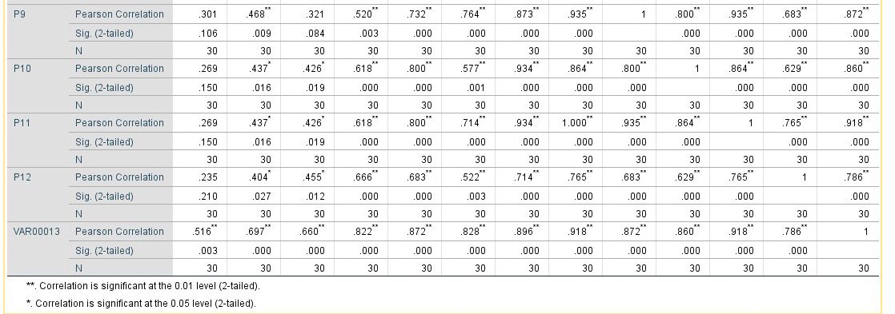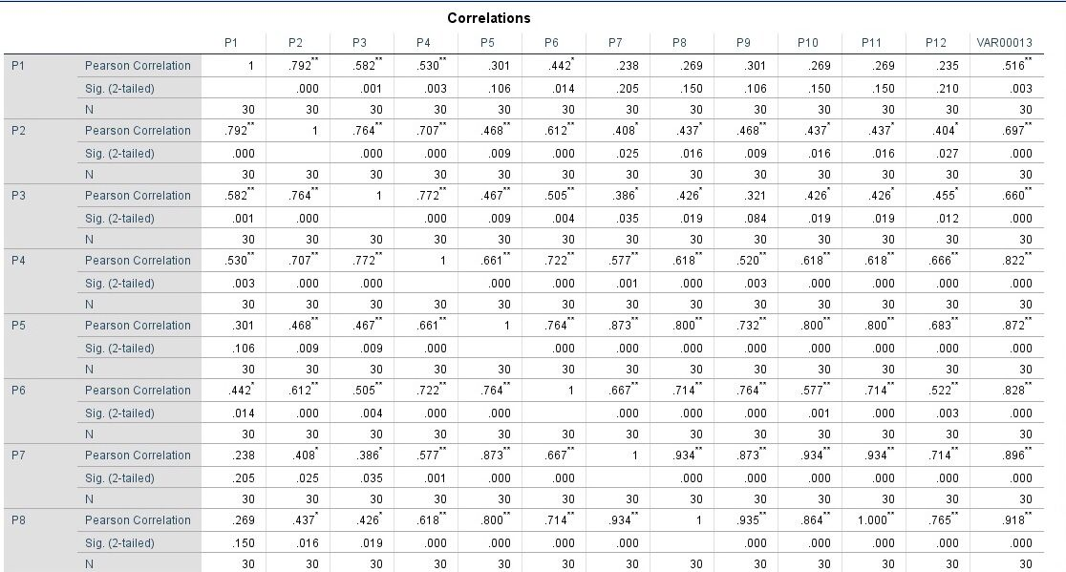

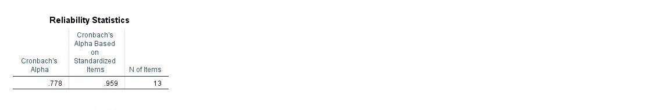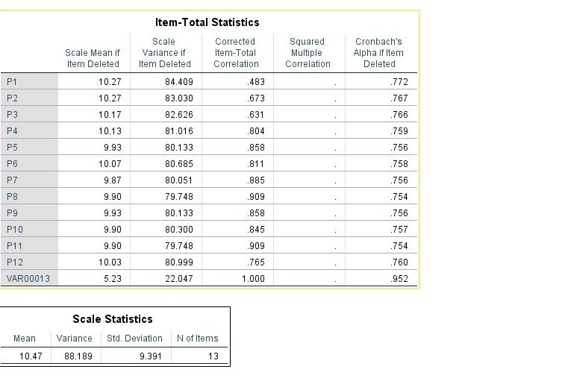

Lampiran 8. Master Tabel Penelitian Pelecehan Seksual

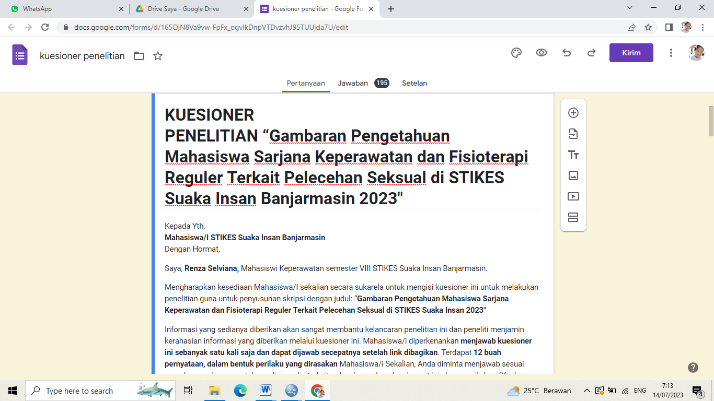

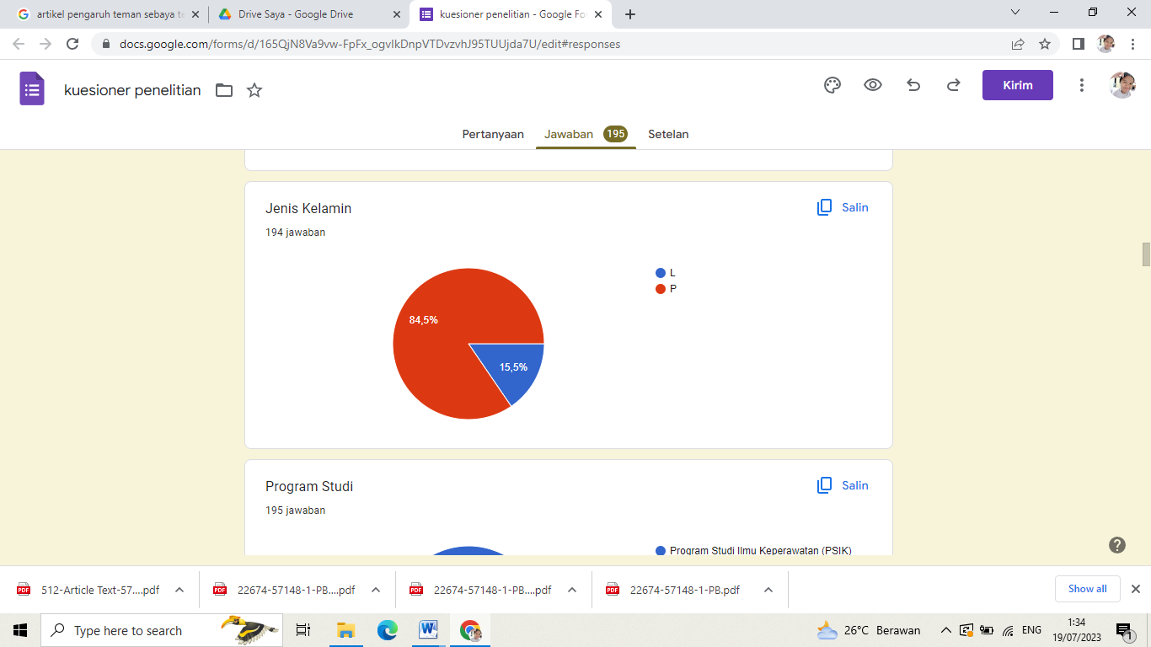

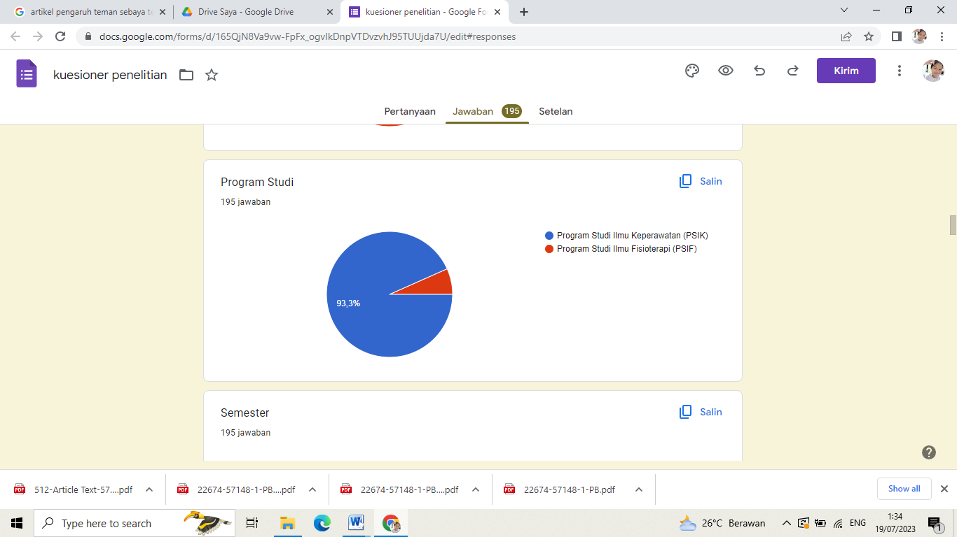

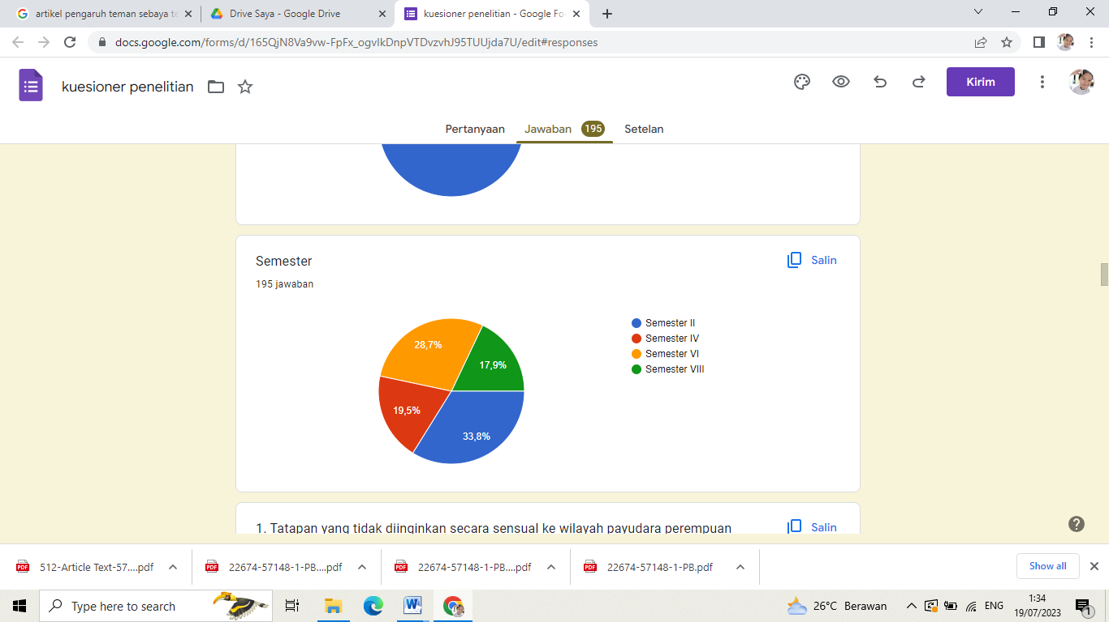

|  |  |  |  |  |  |  |  |  |  |  |  |  |  |  |  |  |  |
| --- | --- | --- | --- | --- | --- | --- | --- | --- | --- | --- | --- | --- | --- | --- | --- | --- | --- |
| **MASTER TABEL DATA PENELITIAN** | | | | | | | | | | | | | | | | | |
| **GAMBARAN PENGETAHUAN MAHASISWA SARJANA KEPERAWATAN DAN FISIOTERAPI REGULER TERKAIT PELECEHAN SEKSUAL** | | | | | | | | | | | | | | | | | |
| **DI STIKES SUAKA INSAN BANJARMASIN TAHUN 2023** | | | | | | | | | | | | | | | | | |
| R | JK | PS | SEMESTER | P1 | P2 | P3 | P4 | P5 | P6 | P7 | P8 | P9 | P10 | P11 | P12 | TOTAL |  |
| R1 | 2 | 2 | 1 | 1 | 1 | 1 | 1 | 1 | 1 | 1 | 1 | 1 | 1 | 1 | 1 | 12 | baik |
| R2 | 2 | 1 | 2 | 1 | 0 | 0 | 0 | 0 | 0 | 0 | 0 | 0 | 0 | 0 | 0 | 1 | buruk |
| R3 | 2 | 1 | 1 | 1 | 0 | 1 | 1 | 0 | 0 | 0 | 0 | 0 | 0 | 0 | 0 | 3 | buruk |
| R4 | 1 | 1 | 1 | 1 | 1 | 1 | 1 | 1 | 1 | 1 | 1 | 1 | 1 | 1 | 1 | 12 | baik |
| R5 | 2 | 1 | 2 | 0 | 0 | 0 | 0 | 0 | 0 | 0 | 0 | 0 | 0 | 0 | 0 | 0 | buruk |
| R6 | 2 | 1 | 1 | 0 | 0 | 0 | 0 | 0 | 0 | 0 | 0 | 0 | 0 | 0 | 0 | 0 | buruk |
| R7 | 2 | 1 | 2 | 0 | 0 | 0 | 0 | 0 | 0 | 0 | 0 | 0 | 0 | 0 | 0 | 0 | buruk |
| R8 | 2 | 1 | 2 | 0 | 0 | 0 | 0 | 0 | 0 | 0 | 0 | 0 | 0 | 0 | 0 | 0 | buruk |
| R9 | 2 | 1 | 3 | 1 | 1 | 1 | 0 | 1 | 1 | 1 | 1 | 1 | 1 | 1 | 1 | 11 | baik |
| R10 | 2 | 1 | 4 | 1 | 1 | 1 | 1 | 1 | 1 | 1 | 1 | 1 | 1 | 1 | 1 | 12 | baik |
| R11 | 2 | 1 | 4 | 0 | 0 | 0 | 0 | 0 | 0 | 0 | 0 | 0 | 0 | 0 | 0 | 0 | buruk |
| R12 | 2 | 1 | 4 | 1 | 1 | 1 | 1 | 1 | 1 | 1 | 1 | 1 | 0 | 0 | 1 | 10 | baik |
| R13 | 2 | 1 | 2 | 1 | 1 | 0 | 1 | 0 | 0 | 0 | 0 | 0 | 0 | 0 | 1 | 4 | buruk |
| R14 | 2 | 1 | 2 | 1 | 1 | 0 | 0 | 0 | 0 | 0 | 0 | 0 | 0 | 0 | 0 | 2 | buruk |
| R15 | 1 | 1 | 2 | 0 | 0 | 0 | 0 | 0 | 0 | 0 | 0 | 0 | 0 | 0 | 0 | 0 | buruk |
| R16 | 2 | 1 | 2 | 1 | 1 | 0 | 0 | 0 | 0 | 0 | 0 | 0 | 0 | 0 | 0 | 2 | buruk |
| R17 | 2 | 1 | 3 | 0 | 0 | 0 | 0 | 0 | 0 | 0 | 0 | 0 | 0 | 0 | 0 | 0 | buruk |
| R18 | 1 | 1 | 2 | 0 | 0 | 0 | 0 | 0 | 0 | 0 | 0 | 0 | 0 | 0 | 0 | 0 | buruk |
| R19 | 2 | 1 | 2 | 0 | 0 | 0 | 0 | 0 | 0 | 0 | 0 | 0 | 0 | 0 | 0 | 0 | buruk |
| R20 | 2 | 1 | 2 | 1 | 1 | 1 | 1 | 0 | 1 | 1 | 1 | 1 | 1 | 1 | 1 | 11 | baik |
| R21 | 2 | 1 | 4 | 1 | 0 | 0 | 0 | 0 | 1 | 1 | 0 | 1 | 0 | 1 | 0 | 5 | buruk |
| R22 | 2 | 1 | 4 | 1 | 1 | 1 | 1 | 1 | 1 | 1 | 1 | 1 | 1 | 1 | 1 | 12 | baik |
| R23 | 2 | 1 | 1 | 1 | 1 | 1 | 0 | 0 | 0 | 0 | 0 | 0 | 0 | 0 | 0 | 3 | buruk |
| R24 | 2 | 1 | 1 | 1 | 1 | 1 | 0 | 0 | 0 | 0 | 0 | 0 | 0 | 0 | 0 | 3 | buruk |
| R25 | 2 | 1 | 4 | 0 | 0 | 0 | 0 | 0 | 0 | 0 | 0 | 0 | 0 | 0 | 0 | 0 | buruk |
| R26 | 2 | 1 | 1 | 1 | 1 | 1 | 1 | 1 | 1 | 1 | 1 | 1 | 1 | 1 | 1 | 12 | baik |
| R27 | 2 | 1 | 4 | 1 | 1 | 1 | 1 | 0 | 0 | 0 | 0 | 0 | 0 | 0 | 0 | 4 | buruk |
| R28 | 2 | 1 | 1 | 1 | 1 | 1 | 1 | 0 | 0 | 0 | 0 | 0 | 0 | 0 | 0 | 4 | buruk |
| R29 | 2 | 1 | 2 | 0 | 0 | 0 | 0 | 0 | 0 | 0 | 0 | 0 | 0 | 0 | 0 | 0 | buruk |
| R30 | 2 | 1 | 1 | 0 | 0 | 0 | 0 | 0 | 0 | 0 | 0 | 0 | 0 | 0 | 0 | 0 | buruk |
| R31 | 2 | 1 | 4 | 1 | 1 | 1 | 1 | 0 | 1 | 1 | 1 | 1 | 1 | 0 | 1 | 10 | baik |
| R32 | 2 | 1 | 1 | 0 | 0 | 0 | 0 | 0 | 0 | 0 | 0 | 0 | 0 | 0 | 0 | 0 | buruk |
| R33 | 2 | 1 | 1 | 0 | 0 | 0 | 0 | 0 | 0 | 0 | 0 | 0 | 0 | 0 | 0 | 0 | buruk |
| R34 | 2 | 1 | 1 | 1 | 1 | 1 | 1 | 0 | 0 | 0 | 0 | 0 | 0 | 0 | 0 | 4 | buruk |
| R35 | 2 | 1 | 4 | 0 | 0 | 1 | 1 | 1 | 1 | 1 | 1 | 1 | 1 | 1 | 1 | 10 | baik |
| R36 | 2 | 1 | 1 | 0 | 0 | 0 | 0 | 0 | 0 | 0 | 0 | 0 | 0 | 0 | 0 | 0 | buruk |
| R37 | 2 | 1 | 1 | 0 | 0 | 0 | 0 | 0 | 0 | 0 | 0 | 0 | 0 | 0 | 0 | 0 | buruk |
| R38 | 2 | 1 | 1 | 1 | 1 | 1 | 1 | 1 | 1 | 1 | 1 | 1 | 1 | 1 | 1 | 12 | baik |
| R39 | 2 | 1 | 1 | 1 | 1 | 1 | 1 | 0 | 0 | 0 | 0 | 0 | 0 | 0 | 1 | 5 | buruk |
| R40 | 2 | 1 | 2 | 1 | 1 | 1 | 1 | 1 | 1 | 1 | 1 | 1 | 1 | 1 | 1 | 12 | baik |
| R41 | 2 | 1 | 1 | 1 | 0 | 0 | 0 | 0 | 0 | 0 | 0 | 0 | 0 | 0 | 0 | 1 | buruk |
| R42 | 2 | 1 | 4 | 1 | 1 | 1 | 1 | 1 | 1 | 0 | 1 | 1 | 1 | 0 | 1 | 10 | baik |
| R43 | 1 | 1 | 4 | 1 | 1 | 1 | 1 | 1 | 1 | 1 | 1 | 1 | 1 | 1 | 1 | 12 | baik |
| R44 | 2 | 1 | 4 | 1 | 1 | 1 | 1 | 1 | 0 | 0 | 0 | 0 | 1 | 0 | 0 | 6 | buruk |
| R45 | 2 | 1 | 4 | 0 | 0 | 0 | 0 | 0 | 0 | 0 | 0 | 0 | 0 | 0 | 0 | 0 | buruk |
| R46 | 2 | 1 | 3 | 1 | 1 | 1 | 0 | 0 | 0 | 0 | 0 | 0 | 0 | 0 | 0 | 3 | buruk |
| R47 | 2 | 1 | 4 | 0 | 0 | 0 | 0 | 0 | 0 | 0 | 0 | 0 | 0 | 0 | 0 | 0 | buruk |
| R48 | 2 | 1 | 2 | 0 | 0 | 0 | 0 | 0 | 0 | 0 | 0 | 0 | 0 | 0 | 0 | 0 | buruk |
| R49 | 2 | 1 | 4 | 1 | 1 | 1 | 1 | 1 | 1 | 1 | 1 | 1 | 1 | 1 | 1 | 12 | baik |
| R50 | 1 | 1 | 1 | 1 | 1 | 1 | 1 | 0 | 0 | 0 | 0 | 0 | 0 | 0 | 0 | 4 | buruk |
| R51 | 2 | 1 | 1 | 0 | 0 | 0 | 0 | 0 | 0 | 0 | 0 | 0 | 0 | 0 | 0 | 0 | buruk |
| R52 | 1 | 1 | 1 | 1 | 1 | 0 | 0 | 0 | 0 | 0 | 0 | 0 | 0 | 0 | 0 | 2 | buruk |
| R53 | 2 | 1 | 1 | 1 | 1 | 1 | 1 | 0 | 0 | 0 | 0 | 0 | 0 | 0 | 0 | 4 | buruk |
| R54 | 1 | 1 | 4 | 1 | 1 | 1 | 1 | 0 | 0 | 0 | 0 | 0 | 0 | 0 | 0 | 4 | buruk |
| R55 | 1 | 1 | 1 | 1 | 1 | 1 | 1 | 0 | 0 | 0 | 0 | 0 | 0 | 0 | 0 | 4 | buruk |
| R56 | 2 | 1 | 4 | 1 | 1 | 0 | 0 | 0 | 1 | 0 | 0 | 0 | 0 | 0 | 0 | 3 | buruk |
| R57 | 2 | 1 | 4 | 1 | 1 | 1 | 1 | 1 | 1 | 0 | 0 | 0 | 0 | 0 | 0 | 6 | buruk |
| R58 | 2 | 1 | 2 | 0 | 0 | 0 | 0 | 0 | 0 | 0 | 0 | 0 | 0 | 0 | 0 | 0 | buruk |
| R59 | 2 | 1 | 1 | 0 | 0 | 0 | 0 | 0 | 0 | 0 | 0 | 0 | 0 | 0 | 0 | 0 | buruk |
| R60 | 2 | 1 | 1 | 0 | 0 | 0 | 0 | 0 | 0 | 0 | 0 | 0 | 0 | 0 | 0 | 0 | buruk |
| R61 | 2 | 1 | 4 | 0 | 0 | 0 | 0 | 0 | 0 | 0 | 0 | 0 | 0 | 0 | 0 | 0 | buruk |
| R62 | 2 | 1 | 1 | 1 | 1 | 1 | 1 | 1 | 1 | 1 | 1 | 1 | 1 | 1 | 1 | 12 | baik |
| R63 | 2 | 1 | 1 | 0 | 0 | 0 | 0 | 0 | 0 | 0 | 0 | 0 | 0 | 0 | 0 | 0 | buruk |
| R64 | 2 | 2 | 1 | 1 | 1 | 1 | 1 | 1 | 1 | 1 | 1 | 1 | 1 | 1 | 1 | 12 | baik |
| R65 | 2 | 1 | 2 | 1 | 1 | 1 | 1 | 1 | 1 | 1 | 1 | 1 | 1 | 1 | 1 | 12 | baik |
| R66 | 2 | 1 | 1 | 0 | 0 | 0 | 0 | 0 | 0 | 0 | 0 | 0 | 0 | 0 | 0 | 0 | buruk |
| R67 | 2 | 1 | 1 | 1 | 1 | 1 | 1 | 1 | 1 | 1 | 1 | 1 | 1 | 1 | 1 | 12 | baik |
| R68 | 2 | 1 | 1 | 0 | 0 | 0 | 0 | 0 | 0 | 0 | 0 | 0 | 0 | 0 | 0 | 0 | buruk |
| R69 | 2 | 1 | 4 | 1 | 1 | 1 | 1 | 0 | 0 | 0 | 0 | 0 | 0 | 0 | 0 | 4 | buruk |
| R70 | 2 | 1 | 4 | 1 | 0 | 1 | 1 | 0 | 1 | 1 | 1 | 1 | 0 | 1 | 1 | 9 | baik |
| R71 | 1 | 1 | 1 | 1 | 1 | 1 | 1 | 1 | 1 | 0 | 0 | 0 | 0 | 0 | 0 | 6 | buruk |
| R72 | 2 | 1 | 1 | 0 | 0 | 0 | 0 | 0 | 0 | 0 | 0 | 0 | 0 | 0 | 0 | 0 | buruk |
| R73 | 1 | 1 | 1 | 0 | 0 | 0 | 0 | 0 | 0 | 0 | 0 | 0 | 0 | 0 | 0 | 0 | buruk |
| R74 | 2 | 1 | 1 | 0 | 0 | 0 | 0 | 0 | 0 | 0 | 0 | 0 | 0 | 0 | 0 | 0 | buruk |
| R75 | 2 | 1 | 1 | 1 | 1 | 1 | 1 | 1 | 1 | 1 | 1 | 1 | 1 | 1 | 1 | 12 | baik |
| R76 | 1 | 1 | 2 | 1 | 1 | 1 | 1 | 1 | 1 | 1 | 1 | 1 | 1 | 1 | 1 | 12 | baik |
| R77 | 1 | 1 | 1 | 0 | 0 | 0 | 0 | 0 | 0 | 0 | 0 | 0 | 0 | 0 | 0 | 0 | buruk |
| R78 | 1 | 1 | 4 | 0 | 0 | 0 | 0 | 0 | 0 | 0 | 0 | 0 | 0 | 0 | 0 | 0 | buruk |
| R79 | 2 | 1 | 2 | 1 | 1 | 1 | 1 | 0 | 0 | 0 | 0 | 0 | 0 | 0 | 0 | 4 | buruk |
| R80 | 1 | 1 | 1 | 1 | 0 | 1 | 1 | 0 | 0 | 0 | 0 | 0 | 0 | 0 | 1 | 4 | buruk |
| R81 | 2 | 1 | 4 | 1 | 1 | 1 | 1 | 1 | 1 | 1 | 1 | 1 | 1 | 1 | 1 | 12 | baik |
| R82 | 2 | 1 | 3 | 1 | 0 | 0 | 0 | 0 | 0 | 0 | 0 | 0 | 0 | 0 | 0 | 1 | buruk |
| R83 | 1 | 1 | 4 | 0 | 0 | 0 | 0 | 0 | 1 | 0 | 0 | 0 | 0 | 0 | 0 | 1 | buruk |
| R84 | 2 | 1 | 4 | 1 | 1 | 1 | 1 | 1 | 1 | 1 | 1 | 1 | 1 | 1 | 1 | 12 | baik |
| R85 | 2 | 1 | 3 | 1 | 1 | 1 | 1 | 1 | 1 | 1 | 1 | 1 | 1 | 1 | 1 | 12 | baik |
| R86 | 2 | 1 | 3 | 1 | 0 | 1 | 1 | 0 | 0 | 0 | 0 | 0 | 0 | 0 | 0 | 3 | buruk |
| R87 | 2 | 1 | 1 | 0 | 0 | 0 | 0 | 0 | 0 | 0 | 0 | 0 | 0 | 0 | 0 | 0 | buruk |
| R88 | 2 | 1 | 2 | 1 | 1 | 0 | 1 | 0 | 0 | 0 | 0 | 0 | 1 | 0 | 0 | 4 | buruk |
| R89 | 2 | 1 | 2 | 1 | 1 | 1 | 1 | 1 | 0 | 0 | 0 | 0 | 0 | 0 | 0 | 5 | buruk |
| R90 | 2 | 1 | 1 | 1 | 1 | 1 | 1 | 1 | 1 | 1 | 1 | 1 | 1 | 1 | 1 | 12 | baik |
| R91 | 2 | 1 | 2 | 0 | 0 | 0 | 0 | 0 | 0 | 0 | 0 | 0 | 0 | 0 | 0 | 0 | buruk |
| R92 | 1 | 1 | 4 | 0 | 0 | 0 | 0 | 0 | 0 | 0 | 0 | 0 | 0 | 0 | 0 | 0 | buruk |
| R93 | 2 | 1 | 2 | 0 | 0 | 0 | 0 | 0 | 0 | 0 | 0 | 0 | 0 | 0 | 0 | 0 | buruk |
| R94 | 1 | 1 | 1 | 0 | 1 | 1 | 1 | 1 | 0 | 0 | 0 | 0 | 0 | 0 | 0 | 4 | buruk |
| R95 | 2 | 1 | 4 | 1 | 1 | 1 | 0 | 0 | 0 | 0 | 0 | 0 | 0 | 0 | 0 | 3 | buruk |
| R96 | 1 | 1 | 4 | 0 | 0 | 1 | 1 | 0 | 0 | 0 | 0 | 0 | 0 | 0 | 0 | 2 | buruk |
| R97 | 2 | 1 | 4 | 0 | 0 | 0 | 0 | 0 | 0 | 0 | 0 | 0 | 0 | 0 | 0 | 0 | buruk |
| R98 | 2 | 1 | 1 | 0 | 0 | 0 | 0 | 0 | 0 | 0 | 0 | 0 | 0 | 0 | 0 | 0 | buruk |
| R99 | 1 | 1 | 3 | 0 | 0 | 0 | 0 | 0 | 0 | 0 | 0 | 0 | 0 | 0 | 0 | 0 | buruk |
| R100 | 2 | 1 | 3 | 1 | 1 | 1 | 1 | 0 | 0 | 0 | 0 | 0 | 0 | 0 | 0 | 4 | buruk |
| R101 | 2 | 1 | 3 | 1 | 1 | 1 | 1 | 1 | 1 | 1 | 1 | 1 | 0 | 1 | 1 | 11 | baik |
| R102 | 2 | 1 | 3 | 1 | 0 | 1 | 1 | 1 | 0 | 0 | 0 | 0 | 0 | 0 | 0 | 4 | buruk |
| R103 | 2 | 1 | 3 | 1 | 1 | 1 | 1 | 1 | 1 | 1 | 1 | 1 | 1 | 1 | 1 | 12 | baik |
| R104 | 2 | 1 | 1 | 0 | 0 | 0 | 0 | 0 | 0 | 0 | 0 | 0 | 0 | 0 | 0 | 0 | buruk |
| R105 | 2 | 1 | 3 | 1 | 1 | 1 | 1 | 1 | 1 | 1 | 1 | 0 | 1 | 1 | 1 | 11 | baik |
| R106 | 2 | 1 | 3 | 0 | 0 | 0 | 0 | 0 | 0 | 0 | 0 | 0 | 0 | 0 | 0 | 0 | buruk |
| R107 | 2 | 1 | 1 | 1 | 1 | 1 | 1 | 1 | 1 | 1 | 1 | 1 | 1 | 1 | 1 | 12 | baik |
| R108 | 2 | 1 | 1 | 1 | 1 | 1 | 1 | 0 | 0 | 0 | 0 | 0 | 0 | 0 | 1 | 5 | buruk |
| R109 | 2 | 1 | 1 | 0 | 0 | 0 | 0 | 0 | 0 | 0 | 0 | 0 | 0 | 0 | 1 | 1 | buruk |
| R110 | 2 | 1 | 3 | 1 | 0 | 1 | 1 | 0 | 1 | 0 | 0 | 0 | 1 | 0 | 0 | 5 | buruk |
| R111 | 2 | 1 | 3 | 1 | 1 | 1 | 1 | 1 | 1 | 1 | 1 | 0 | 0 | 0 | 0 | 8 | baik |
| R112 | 2 | 1 | 1 | 1 | 1 | 1 | 1 | 0 | 0 | 0 | 0 | 0 | 0 | 0 | 1 | 5 | buruk |
| R113 | 2 | 1 | 1 | 1 | 1 | 1 | 1 | 0 | 0 | 0 | 0 | 0 | 0 | 0 | 0 | 4 | buruk |
| R114 | 2 | 1 | 3 | 1 | 1 | 0 | 0 | 1 | 1 | 0 | 0 | 0 | 0 | 0 | 0 | 4 | buruk |
| R115 | 2 | 1 | 3 | 0 | 0 | 0 | 0 | 0 | 0 | 0 | 0 | 0 | 0 | 0 | 0 | 0 | buruk |
| R116 | 2 | 1 | 2 | 1 | 1 | 1 | 1 | 1 | 1 | 0 | 1 | 0 | 1 | 0 | 1 | 9 | baik |
| R117 | 2 | 1 | 3 | 1 | 1 | 1 | 1 | 0 | 0 | 0 | 0 | 0 | 0 | 0 | 0 | 4 | buruk |
| R118 | 2 | 1 | 3 | 1 | 1 | 1 | 1 | 1 | 1 | 1 | 1 | 1 | 1 | 1 | 1 | 12 | baik |
| R119 | 1 | 1 | 3 | 1 | 1 | 1 | 1 | 1 | 1 | 1 | 1 | 1 | 1 | 1 | 0 | 11 | baik |
| R120 | 2 | 1 | 2 | 1 | 1 | 1 | 1 | 0 | 0 | 0 | 0 | 0 | 0 | 0 | 1 | 5 | buruk |
| R121 | 1 | 1 | 3 | 1 | 1 | 1 | 1 | 1 | 1 | 1 | 1 | 1 | 1 | 1 | 1 | 12 | baik |
| R122 | 1 | 1 | 3 | 1 | 1 | 1 | 1 | 1 | 1 | 1 | 1 | 1 | 1 | 1 | 0 | 11 | baik |
| R123 | 1 | 1 | 3 | 1 | 1 | 1 | 1 | 0 | 1 | 0 | 0 | 0 | 1 | 0 | 1 | 7 | baik |
| R124 | 2 | 1 | 4 | 1 | 1 | 1 | 1 | 1 | 1 | 1 | 1 | 1 | 1 | 1 | 1 | 12 | baik |
| R125 | 2 | 1 | 2 | 1 | 1 | 1 | 1 | 0 | 0 | 0 | 0 | 0 | 0 | 0 | 0 | 4 | buruk |
| R126 | 2 | 1 | 3 | 1 | 1 | 1 | 1 | 1 | 1 | 1 | 1 | 1 | 1 | 1 | 1 | 12 | baik |
| R127 | 1 | 1 | 3 | 1 | 0 | 0 | 0 | 0 | 0 | 0 | 0 | 0 | 0 | 0 | 0 | 1 | buruk |
| R128 | 2 | 1 | 1 | 0 | 0 | 0 | 0 | 0 | 0 | 0 | 0 | 0 | 0 | 0 | 1 | 1 | buruk |
| R129 | 2 | 1 | 3 | 1 | 1 | 1 | 1 | 0 | 0 | 0 | 0 | 0 | 1 | 0 | 0 | 5 | buruk |
| R130 | 2 | 1 | 3 | 1 | 1 | 1 | 1 | 0 | 0 | 0 | 0 | 0 | 0 | 0 | 0 | 4 | buruk |
| R131 | 2 | 2 | 2 | 1 | 1 | 1 | 1 | 1 | 1 | 1 | 1 | 1 | 1 | 1 | 0 | 11 | baik |
| R132 | 2 | 2 | 1 | 1 | 0 | 1 | 1 | 0 | 0 | 0 | 1 | 1 | 1 | 1 | 0 | 7 | baik |
| R133 | 2 | 2 | 1 | 0 | 0 | 0 | 0 | 0 | 0 | 0 | 0 | 0 | 0 | 0 | 1 | 1 | buruk |
| R134 | 2 | 2 | 1 | 1 | 1 | 0 | 0 | 0 | 0 | 0 | 0 | 0 | 0 | 0 | 1 | 3 | buruk |
| R135 | 2 | 2 | 2 | 1 | 1 | 1 | 1 | 1 | 1 | 1 | 1 | 1 | 1 | 1 | 0 | 11 | baik |
| R136 | 2 | 2 | 1 | 1 | 1 | 1 | 1 | 0 | 0 | 0 | 0 | 0 | 0 | 0 | 0 | 4 | buruk |
| R137 | 2 | 2 | 2 | 0 | 0 | 0 | 0 | 0 | 0 | 0 | 0 | 0 | 0 | 0 | 1 | 1 | buruk |
| R138 | 2 | 2 | 1 | 1 | 0 | 0 | 0 | 0 | 0 | 0 | 0 | 0 | 0 | 0 | 0 | 1 | buruk |
| R139 | 2 | 2 | 1 | 1 | 1 | 1 | 1 | 1 | 1 | 1 | 1 | 1 | 1 | 1 | 0 | 11 | baik |
| R140 | 2 | 2 | 2 | 1 | 1 | 1 | 1 | 1 | 1 | 1 | 1 | 1 | 0 | 1 | 0 | 10 | baik |
| R141 | 2 | 2 | 2 | 1 | 1 | 1 | 1 | 1 | 1 | 1 | 1 | 1 | 1 | 1 | 1 | 12 | baik |
| R142 | 2 | 1 | 4 | 0 | 0 | 0 | 0 | 0 | 1 | 0 | 0 | 0 | 0 | 0 | 1 | 2 | buruk |
| R143 | 2 | 1 | 3 | 1 | 1 | 1 | 1 | 1 | 1 | 1 | 1 | 1 | 1 | 1 | 1 | 12 | baik |
| R144 | 2 | 1 | 3 | 1 | 1 | 1 | 1 | 1 | 1 | 1 | 1 | 1 | 1 | 1 | 0 | 11 | baik |
| R145 | 2 | 1 | 3 | 1 | 0 | 0 | 0 | 0 | 0 | 0 | 0 | 0 | 0 | 0 | 1 | 2 | buruk |
| R146 | 2 | 1 | 3 | 0 | 0 | 1 | 0 | 0 | 0 | 0 | 0 | 0 | 0 | 0 | 1 | 2 | buruk |
| R147 | 2 | 1 | 3 | 1 | 1 | 1 | 1 | 0 | 0 | 0 | 0 | 1 | 1 | 1 | 0 | 7 | baik |
| R148 | 2 | 1 | 3 | 1 | 1 | 0 | 0 | 0 | 0 | 0 | 0 | 0 | 0 | 0 | 0 | 2 | buruk |
| R149 | 2 | 1 | 3 | 1 | 0 | 1 | 1 | 0 | 0 | 0 | 0 | 0 | 0 | 0 | 1 | 4 | buruk |
| R150 | 2 | 1 | 3 | 0 | 1 | 0 | 1 | 0 | 0 | 0 | 0 | 0 | 0 | 0 | 0 | 2 | buruk |
| R151 | 1 | 1 | 3 | 1 | 1 | 1 | 1 | 0 | 0 | 0 | 0 | 0 | 0 | 0 | 0 | 4 | buruk |
| R152 | 1 | 1 | 1 | 1 | 1 | 1 | 1 | 1 | 1 | 1 | 1 | 1 | 1 | 1 | 1 | 12 | baik |
| R153 | 1 | 1 | 3 | 0 | 0 | 0 | 0 | 0 | 0 | 0 | 0 | 0 | 0 | 0 | 0 | 0 | buruk |
| R154 | 1 | 1 | 1 | 1 | 1 | 1 | 1 | 1 | 1 | 1 | 1 | 1 | 1 | 1 | 1 | 12 | baik |
| R155 | 2 | 1 | 3 | 0 | 1 | 1 | 1 | 1 | 0 | 0 | 1 | 1 | 1 | 0 | 0 | 7 | baik |
|  |  |  |  |  |  |  |  |  |  |  |  |  |  |  |  |  |  |
|  |  |  |  |  |  |  |  |  |  |  |  |  |  |  |  |  |  |
|  | JK | PS | SEM |  |  |  |  |  |  |  |  |  |  |  |  |  |  |
|  | 1= 28 | 1=142 | 1=56 |  |  |  |  |  |  |  |  |  |  |  |  | baik = 51 | |
|  | 2= 127 | 2=13 | 2=30 |  |  |  |  |  |  |  |  |  |  |  |  | buruk = 104 | |
|  |  |  | 3=38 |  |  |  |  |  |  |  |  |  |  |  |  |  |  |
|  |  |  | 4=31 |  |  |  |  |  |  |  |  |  |  |  |  |  |  |

**Frekuensi Data Mahasiswa**

|  |  |  |  |  |  |
| --- | --- | --- | --- | --- | --- |
| **Jenis kelamin** | | | | | |
|  | | Frequency | Percent | Valid Percent | Cumulative Percent |
| Valid | LAKI-LAKI | 28 | 18.1 | 18.1 | 18.1 |
| PEREMPUAN | 127 | 81.9 | 81.9 | 100.0 |
| Total | 155 | 100.0 | 100.0 |  |

|  |  |  |  |  |  |
| --- | --- | --- | --- | --- | --- |
| **Program study** | | | | | |
|  | | Frequency | Percent | Valid Percent | Cumulative Percent |
| Valid | PERAWAT | 142 | 91.6 | 91.6 | 91.6 |
| FISIOTERAPI | 13 | 8.4 | 8.4 | 100.0 |
| Total | 155 | 100.0 | 100.0 |  |

|  |  |  |  |  |  |
| --- | --- | --- | --- | --- | --- |
| **Semester** | | | | | |
|  | | Frequency | Percent | Valid Percent | Cumulative Percent |
| Valid | SEMESTER II | 56 | 36.1 | 36.1 | 36.1 |
| SEMESTER IV | 30 | 19.4 | 19.4 | 55.5 |
| SEMESTER VI | 38 | 24.5 | 24.5 | 80.0 |
| SEMESTER VIII | 31 | 20.0 | 20.0 | 100.0 |
| Total | 155 | 100.0 | 100.0 |  |

|  |  |  |  |  |  |
| --- | --- | --- | --- | --- | --- |
| **P1** | | | | | |
|  | | Frequency | Percent | Valid Percent | Cumulative Percent |
| Valid | YA | 100 | 64.5 | 64.5 | 64.5 |
| TIDAK | 55 | 35.5 | 35.5 | 100.0 |
| Total | 155 | 100.0 | 100.0 |  |

|  |  |  |  |  |  |
| --- | --- | --- | --- | --- | --- |
| **P2** | | | | | |
|  | | Frequency | Percent | Valid Percent | Cumulative Percent |
| Valid | YA | 88 | 56.8 | 56.8 | 56.8 |
| TIDAK | 67 | 43.2 | 43.2 | 100.0 |
| Total | 155 | 100.0 | 100.0 |  |

|  |  |  |  |  |  |
| --- | --- | --- | --- | --- | --- |
| **P3** | | | | | |
|  | | Frequency | Percent | Valid Percent | Cumulative Percent |
| Valid | YA | 89 | 57.4 | 57.4 | 57.4 |
| TIDAK | 66 | 42.6 | 42.6 | 100.0 |
| Total | 155 | 100.0 | 100.0 |  |

|  |  |  |  |  |  |
| --- | --- | --- | --- | --- | --- |
| **P4** | | | | | |
|  | | Frequency | Percent | Valid Percent | Cumulative Percent |
| Valid | YA | 86 | 55.5 | 55.5 | 55.5 |
| TIDAK | 69 | 44.5 | 44.5 | 100.0 |
| Total | 155 | 100.0 | 100.0 |  |

|  |  |  |  |  |  |
| --- | --- | --- | --- | --- | --- |
| **P5** | | | | | |
|  | | Frequency | Percent | Valid Percent | Cumulative Percent |
| Valid | YA | 52 | 33.5 | 33.5 | 33.5 |
| TIDAK | 103 | 66.5 | 66.5 | 100.0 |
| Total | 155 | 100.0 | 100.0 |  |

|  |  |  |  |  |  |
| --- | --- | --- | --- | --- | --- |
| **P6** | | | | | |
|  | | Frequency | Percent | Valid Percent | Cumulative Percent |
| Valid | YA | 56 | 36.1 | 36.1 | 36.1 |
| TIDAK | 99 | 63.9 | 63.9 | 100.0 |
| Total | 155 | 100.0 | 100.0 |  |

|  |  |  |  |  |  |
| --- | --- | --- | --- | --- | --- |
| **P7** | | | | | |
|  | | Frequency | Percent | Valid Percent | Cumulative Percent |
| Valid | YA | 46 | 29.7 | 29.7 | 29.7 |
| TIDAK | 109 | 70.3 | 70.3 | 100.0 |
| Total | 155 | 100.0 | 100.0 |  |

|  |  |  |  |  |  |
| --- | --- | --- | --- | --- | --- |
| **P8** | | | | | |
|  | | Frequency | Percent | Valid Percent | Cumulative Percent |
| Valid | YA | 49 | 31.6 | 31.6 | 31.6 |
| TIDAK | 106 | 68.4 | 68.4 | 100.0 |
| Total | 155 | 100.0 | 100.0 |  |

|  |  |  |  |  |  |
| --- | --- | --- | --- | --- | --- |
| **P9** | | | | | |
|  | | Frequency | Percent | Valid Percent | Cumulative Percent |
| Valid | YA | 48 | 31.0 | 31.0 | 31.0 |
| TIDAK | 107 | 69.0 | 69.0 | 100.0 |
| Total | 155 | 100.0 | 100.0 |  |

|  |  |  |  |  |  |
| --- | --- | --- | --- | --- | --- |
| **P10** | | | | | |
|  | | Frequency | Percent | Valid Percent | Cumulative Percent |
| Valid | YA | 50 | 32.3 | 32.3 | 32.3 |
| TIDAK | 105 | 67.7 | 67.7 | 100.0 |
| Total | 155 | 100.0 | 100.0 |  |

|  |  |  |  |  |  |
| --- | --- | --- | --- | --- | --- |
| **P11** | | | | | |
|  | | Frequency | Percent | Valid Percent | Cumulative Percent |
| Valid | YA | 45 | 29.0 | 29.0 | 29.0 |
| TIDAK | 110 | 71.0 | 71.0 | 100.0 |
| Total | 155 | 100.0 | 100.0 |  |

|  |  |  |  |  |  |
| --- | --- | --- | --- | --- | --- |
| **P11** | | | | | |
|  | | Frequency | Percent | Valid Percent | Cumulative Percent |
| Valid | YA | 45 | 29.0 | 29.0 | 29.0 |
| TIDAK | 110 | 71.0 | 71.0 | 100.0 |
| Total | 155 | 100.0 | 100.0 |  |

|  |  |  |  |  |  |
| --- | --- | --- | --- | --- | --- |
| **P12** | | | | | |
|  | | Frequency | Percent | Valid Percent | Cumulative Percent |
| Valid | YA | 55 | 35.5 | 35.5 | 35.5 |
| TIDAK | 100 | 64.5 | 64.5 | 100.0 |
| Total | 155 | 100.0 | 100.0 |  |

Lampiran 9. Peminjaman Kuesioner

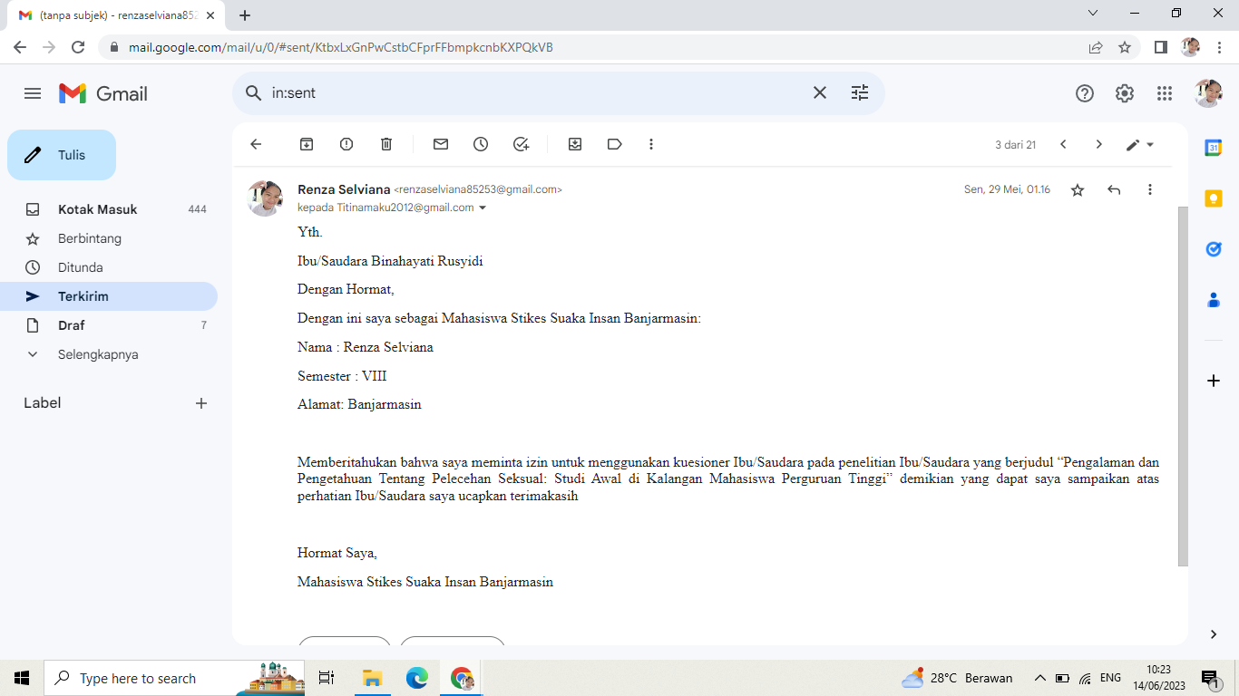



**PROGRAM STUDI ILMU KEPERAWATAN DAN PROFESI NERS**

**SEKOLAH TINGGI ILMU KESEHATAN SUAKA INSAN**

**BANJARMASBANJARMASIN TAHUN AKADEMIK 2022/2023**

**LEMBAR KONSULTASI PROPOSAL DAN SKRIPSI**

Nama Mahasiswa : Renza Selviana

NIM : 113063C119041

Pembimbing I : Sr. Margaretha Martini,SPC.BSN.MSN

Judul : Gambaran Pengetahuan Mahasiswa Sarjana Keperawatan dan Fisioterapi Regular Terkait Pelecehan Seksual di Kampus Stikes Suaka Insan Bnajarmasin 2023.

|  |  |  |  |
| --- | --- | --- | --- |
| Tanggal Bimbingan | Komponen BAB | Saran | Paraf |
| 14 Juni 2023 | Proposal | Proposal sudah di perbiki dan ajukan etik. |  |
| 16 Juni 2023 | Uji etik dan penelitian | Acc untuk melakukan pengajuan uji etik setelah uji etik keluar, lakukan pengajuan uji valid dan penelitian |  |
| 22 Juni 2023 | Uji etik dan penelitian | Lakukan laporan terkait hasil uji valid dan penelitian. |  |
| 26 Juni 2023 | Kata pengantar | -Abstrak di kata kunci tambahkan subjek.  -serta tambahkan responden dikata pengantar.  -Daftar gambar dan tulisan lampiran dihilangkan. |  |
| 1 Juli 2023 | Bab 1 | Keaslian penelitian diperbaiki. |  |
| 10 Juli 2023  15 Juli 2023  18 Juli 2023 | Bab II  Bab 4  ACC | Sumber dari kerangka teori diganti dan perbaiki skema.  Ubah menjadi visi dan misi dan cek jumlah populasi  ACC |  |