**Lampiran 1**

**LEMBAR PENJELASAN KEPADA RESPONDEN PENELITIAN**

Dengan Hormat,

Saya, Erlina mahasiswi Stikes Suaka Insan Banjarmasin angkatan 13 tahun 2019. Saat ini sedang melakukan penelitian dengan judul “ Hubungan Kualitas Tidur Dengan Peningkatan Tekanan Darah Pada Lansia Di Puskesmas Teluk Dalam Banjarmasin tahun 2023”.

Tujuan penelitian ini adalah untuk mengetahui hubungan antara hubungan kualitas tidur dengan peningkatan tekanan darah pada lansia hipertensi di puskesmas Teluk Dalam Banjarmasin. Untuk itu, saya mohon kesediaan untuk berpartisipasi dalam penelitian ini. Saya mohon untk dapat berpartisipasi dalam menjawab pertanyaan dalam bentuk kuesioner sesuai dengan petunjuk yang diberikan. Jika bersedia, silahkan menandatangani lembar persetujuan ini sebagai bukti kesukarelaan.

Identitas pribadi anda sebagai partisipan akan disamarkan, kerahasiaan data anda akan dijamin sepenuhnya dan semua informasi yang anda berikan hanya akan digunakan untuk penelitian ini. Bila terdapat hal yang kurang dimengerti, anda dapat bertanya kepada saya atau dapat mengubungi saya di nomor 082143474920.

Demikian informasi ini saya sampaikan, atas bantuan partisiapan dan kesediaan and, saya ucapkan terima kasih.

Hormat saya, Peneliti

Erlina

**Lampiran 2**

**PERTANYAAN KESEDIAAN UNTUK MENJADI RESPONDEN**

**( *INFORMED CONSENT)***

Yang bertanda tangan dibawah ini, saya :

Nama :

Umur :

Alamat :

Setelah mendapat penjelasan tentang maksud dan tujuan serta memahami penelitian yang dilakukan dengan judul :

**Hubungan Kualitas Tidur Dengan Tekanan Darah Lansia Di Puskesmas Teluk Dalam Banjarmasin 2023.**

Yang dibuat oleh :

Nama : Erlina

NIM : 113063C119024

Dengan ini saya menyatakan kesediaan untuk berperan serta menjadi subjek penelitian dan bersedia melakukan wawancara sesuai dengan data yang diperlukan.

Demikian pernyataan ini saya buat dengan penuh kesadaran tanpa ada paksaan dari pihak manapun.

Banjarmasin,.................................2023

Responden

**Lampiran 3**

**KUESIONER PENELITIAN**

*Pittsburgh Sleep Quality Index (PSQI)*

**PETUNJUK**

Pertanyaan dibawah ini terkait dengan kebiasaan tidur anda dalam sebulan ini. Jawablah seluruh pertanyaan dengan akurat sehingga dapat mengindikasikan mengenai kebiasaan tidur anda dalam sebulan ini.

IDENTITAS RESPONDEN

Nama :

Umur :

Jenis Kelamin :

Tekanan Darah :

**A. Jawablah pertanyaan berikut ini ! selain pertanyaan no 1 dan 3 Berikan tanda (🗸) pada salah satu jawaban yang anda anggap paling sesuai !**

|  |  |  |  |  |  |
| --- | --- | --- | --- | --- | --- |
| 1 | Jam berapa biasanya anda tidur pada malam hari ? |  | | | |
|  | | <15 menit | 16-30 menit | 31-60 menit | >60 menit |
| 2 | Berapa lama (dalam menit) anda perlukan waktu untuk dapat mulai tertidur setiap malam ?  **Waktu yang dibutuhkan saat mulai berbaring hingga tertidur** |  |  |  |  |
| 3 | Jam berapa biasanya anda bangun di pagi hari ? |  | | | |
|  | | >7 jam | 6-7 jam | 5-6 jam | <5 jam |
| 4 | Berapa jam lama tidur anda pada malam hari (hal ini mungkin berbeda dengan jumlah jam yang anda habiskan ditempat tidur )  **Jumlah jam tidur per malam** |  |  |  |  |

**B. Berikan tanda (🗸) pada salah satu jawaban yang anda anggap paling sesuai !**

|  |  |  |  |  |  |
| --- | --- | --- | --- | --- | --- |
| 5. | Selama sebulan terakhir, seberapa sering anda mengalami hal di bawah ini : | **Tidak Pernah** | **1x Seminggu** | **2x Seminggu** | **>3x Seminggu** |
| a. Tidak dapat tidur dimalam hari dalam waktu 30 menit |  |  |  |  |
| b. Bangun tengah malam atau dini hari (subuh) |  |  |  |  |
| c. Harus bangun untuk ke kamar mandi |  |  |  |  |
| d. Tidak dapat bernafas dengan nyaman |  |  |  |  |
| e. Batuk atau mendengkur keras |  |  |  |  |
| f. Merasa kedinginan |  |  |  |  |
| g. Merasa kepanasan |  |  |  |  |
| h. Mimpi buruk |  |  |  |  |
| i. Merasakan nyeri |  |  |  |  |
| j. Tolong jelaskan penyebab lain yang belum di sebutkan yang menyebabkan anda terganggu di malam hari dan seberapa sering anda mengalaminya ? |  |  |  |  |
| 6 | Selama sebulan terakhir, seberapa sering anda mengonsumsi obat tidur (diresepkan oleh dokter ataupun bebas) untuk membantu anda tidur ? |  |  |  |  |
| 7 | Selama sebulan terakhir, seberapa sering anda merasa terjaga atau mengantuk ketika anda melakukan aktivitas ? |  |  |  |  |
|  | | **Sangat baik** | **Cukup baik** | **Cukup buruk** | **Sangat buruk** |
| 8 | Selama sebulan terakhir, bagaimana anda menilai kebutuhan tidur anda selama ini ? |  |  |  |  |
|  | | **Tidak ada masalah** | **Hanya masalah kecil** | **Masalah sedang** | **Masalah besar** |
| 9 | Selama sebulan terakhir, adakah masalah yang anda rasakan untuk bisa berkonsentrasi dan semangat untuk menyelesaikan suatu pekerjaan/tugas ? |  |  |  |  |

**Lampiran 4**

**Kisi-kisi Instrumen Penelitian PSQI**

|  |  |  |  |
| --- | --- | --- | --- |
| Komponen | No Item | Penilaian | |
| Kualitas Tidur secara subyektif | 8 | Sangat baik | 0 |
| Cukup baik | 1 |
| Cukup buruk | 2 |
| Sangat buruk | 3 |
| Durasi tidur (lamanya waktu tidur) | 4 | >7 jam | 0 |
| 6-7 jam | 1 |
| 5-6 jam | 2 |
| <5 jam | 3 |
| Latensi tidur | 2 | ≤ 15 menit | 0 |
| 16-30 menit | 1 |
| 31-60 menit | 2 |
| >60 menit | 3 |
| 5a | Tidak pernah | 0 |
| 1x seminggu | 1 |
| 2x seminggu | 2 |
| ≥3x seminggu | 3 |
| Skor total komponen 3 | 0 | 0 |
| 1 – 2 | 1 |
| 3 – 4 | 2 |
| 5 – 6 | 3 |
| Efisiensi tidur Rumus:  Durasi tidur (4) x 100% Jam bangun pagi (3) – Jam tidur  malam (1) | 1+3+4 | >85% | 0 |
| 75-84% | 1 |
| 65-74% | 2 |
| <65% | 3 |
| Gangguan tidur | 5b, 5c, 5d,  5e, 5f, 5g, 5h, 5i, 5j | Tidak pernah | 0 |
| 1x seminggu | 1 |
| 2x seminggu | 2 |
| ≥3x seminggu | 3 |

|  |  |  |  |
| --- | --- | --- | --- |
|  | Skor total Komponen 5 | 0 | 0 |
| 1-9 | 1 |
| 10-18 | 2 |
| 19-27 | 3 |
| Penggunaan obat tidur | 6 | 0 | 0 |
| 1-2 | 1 |
| 3-4 | 2 |
| 5-6 | 3 |
| Disfungsi siang hari | 7 | 0 | 0 |
| <1 | 1 |
| 1-2 | 2 |
| >3 | 3 |
| 9 | Tidak ada  masalah | 0 |
| Hanya masalah  kecil | 1 |
| Masalah  sedang | 2 |
| Masalah besar | 3 |
| Skor total Komponen 7 | 0 | 0 |
| 1-2 | 1 |
| 3-4 | 2 |
| 5-6 | 3 |
| Skor Global PSQI | 0-21 | | |

Keterangan Kolom Nilai Skor:

0 = Sangat Baik 1 = Cukup Baik 2 = Agak Buruk 3 = Sanga Buruk

Untuk menentukan Skor akhir yang menyimpulkan kualitas Tidur keseluruhan: Jumlahkan semua hasil skor mulai dari komponen 1 sampai 7 dengan hasil ukur:

Skor 1-5 = baik

Skor 6-7 = ringan

Skor = 8-14 = sedang

Skor 15-21 = Buruk

**Lampiran 6**

**Surat Ijin Validitas dan Reabilitas dari Koordinator Riset**

**SEKOLAH TINGGI ILMU KESEHATAN SUAKA INSAN BANJARMASIN LEMBAGA PENELITIAN DAN PENGABDIAN MASYARAKAT**

Jalan Haji Zafri Zam – Zam No. 8 Banjarmasin Telp. (0511) 3361654 Website: <http://lppm.stikessuakainsan.ac.id/>

Email: [lppm@stikessuakainsan.ac.id](mailto:lppm@stikessuakainsan.ac.id) / [lppmstikessuakainsan@gmail.com](mailto:lppmstikessuakainsan@gmail.com)

|  |  |  |
| --- | --- | --- |
| Nomor | : 119/Riset/STIKES-SI/VI/2023 | Banjarmasin, 20 Juni 2023 |
| Lampiran | : - |  |
| Perihal | : Permohonan Izin Uji Validitas dan Reabilitas |  |

Kepada Yth :

Kepala Puskesmas Pekauman Di – Tempat

Dengan Hormat,

Sehubungan dengan penyelesaian tugas akhir akademik bagi mahasiswa Sarjana Keperawatan STIKES Suaka Insan Banjarmasin, maka kami memohon agar mahasiswa di bawah ini diperkenankan untuk melakukan Uji Validitas dan Reabilitas Instrumen.

Adapun mahasiswa yang akan melaksanakan:

Nama : Erlina

NIM : 113063C119024

Program : Sarjana keperawatan

Topik Penelitian : “Hubungan kualitas tidur dengan peningkatan tekanan darah

lansia hipertensi di wilayah kerja Puskesmas Teluk Dalam Banjarmasin 2023”

Waktu : 21 Juni 2023 – 30 Juni 2023

Demikian permohonan ini dibuat untuk dipergunakan sebagaimana mestinya. Atas perhatian dan kerjasamanya kami ucapkan banyak terimakasih.

Banjarmasin, 20 Juni 2023 STIKES SUAKA INSAN

Koordinator Riset

Ermeisi Er Unja, Ners. M. Kep

Tembusan :

1. Arsip

**Lampiran 7**

**Surat Ijin Penelitian Koordinator Riset**

**SEKOLAH TINGGI ILMU KESEHATAN SUAKA INSAN BANJARMASIN LEMBAGA PENELITIAN DAN PENGABDIAN MASYARAKAT**

Jalan Haji Zafri Zam – Zam No. 8 Banjarmasin Telp. (0511) 3361654 Website: <http://lppm.stikessuakainsan.ac.id/>

Email: [lppm@stikessuakainsan.ac.id](mailto:lppm@stikessuakainsan.ac.id) / [lppmstikessuakainsan@gmail.com](mailto:lppmstikessuakainsan@gmail.com)

Nomor : 120/Riset/STIKES-SI/VI/2023 Banjarmasin, 20 Juni 2023 Lampiran : -

Perihal : Permohonan Izin Penelitian

Kepada Yth :

Kepala Dinas Kesehatan Kota Banjarmasin

Di – Tempat Dengan Hormat,

Sehubungan dengan penyelesaian tugas akhir akademik bagi mahasiswa Sarjana Keperawatan STIKES Suaka Insan Banjarmasin, maka kami memohon agar mahasiswa di bawah ini diperkenankan untuk melakukan penelitian dan pengumpulan data.

Adapun mahasiswa yang akan melaksanakan:

Nama : Erlina

NIM : 113063C119024

Program : Sarjana keperawatan

Topik Penelitian : “Hubungan kualitas tidur dengan peningkatan tekanan darah

lansia hipertensi di wilayah kerja Puskesmas Teluk Dalam Banjarmasin 2023”

Waktu : 21 Juni 2023 – 05 Juli 2023

Demikian permohonan ini dibuat untuk dipergunakan sebagaimana mestinya. Atas perhatian dan kerjasamanya kami ucapkan banyak terimakasih.

Banjarmasin, 20 Juni 2023 STIKES SUAKA INSAN

Koordinator Riset

Ermeisi Er Unja, Ners. M. Kep

Tembusan :

1. Kepala Puskesmas Teluk Dalam Banjarmasin
2. Kepala Puskesmas Pekauman Banjarmasin

**Lampiran 8**

**Surat Ijin Uji Validitas dan reabilitas dan Surat ijin Penelitian dari Kesbangpol dan Dinas Kesehatan**

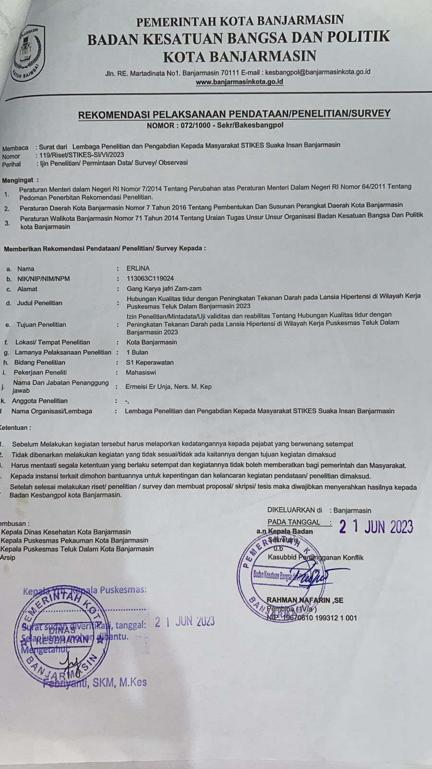

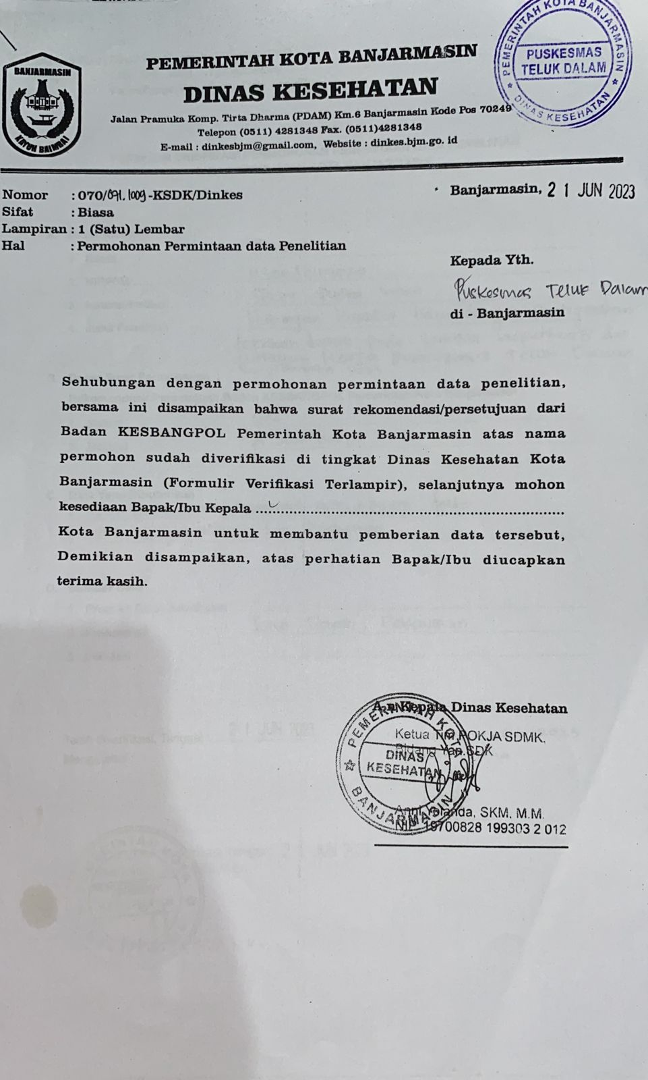

**Lampiran 9**

**Dokumentasi Uji Validitas dan Reabilitas di Puskesmas Pekauman dan Dokementasi Penelitian Puskesmas Teluk Dalam**

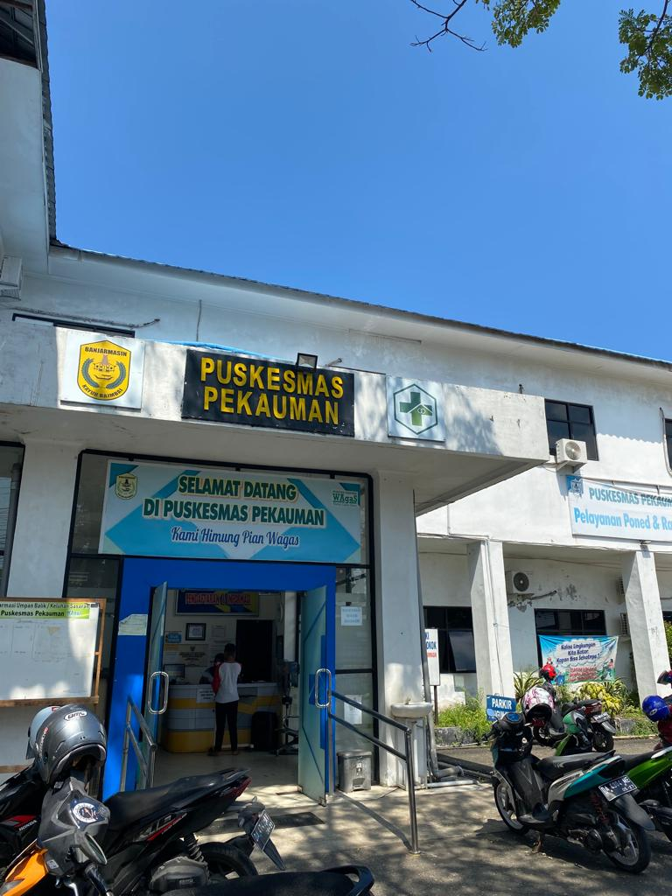

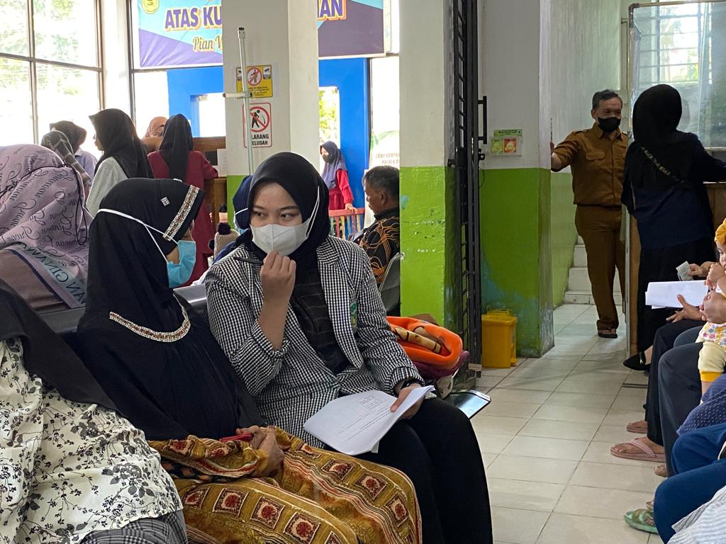

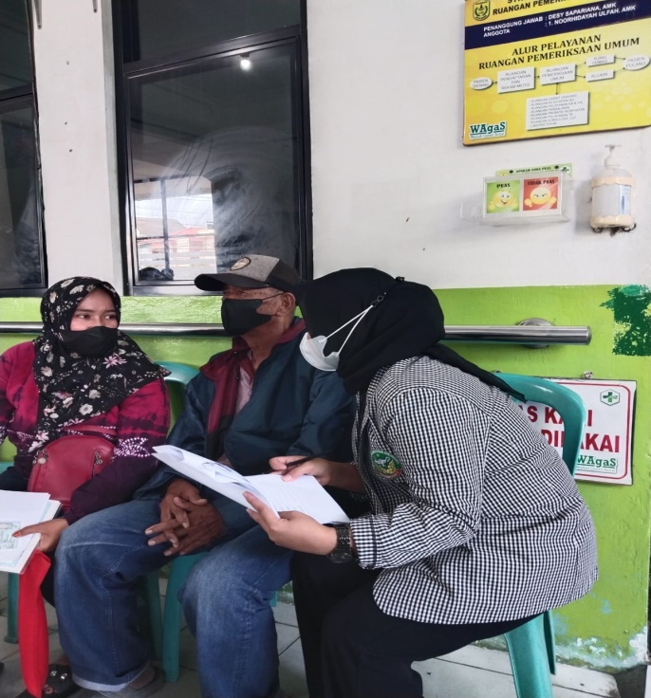 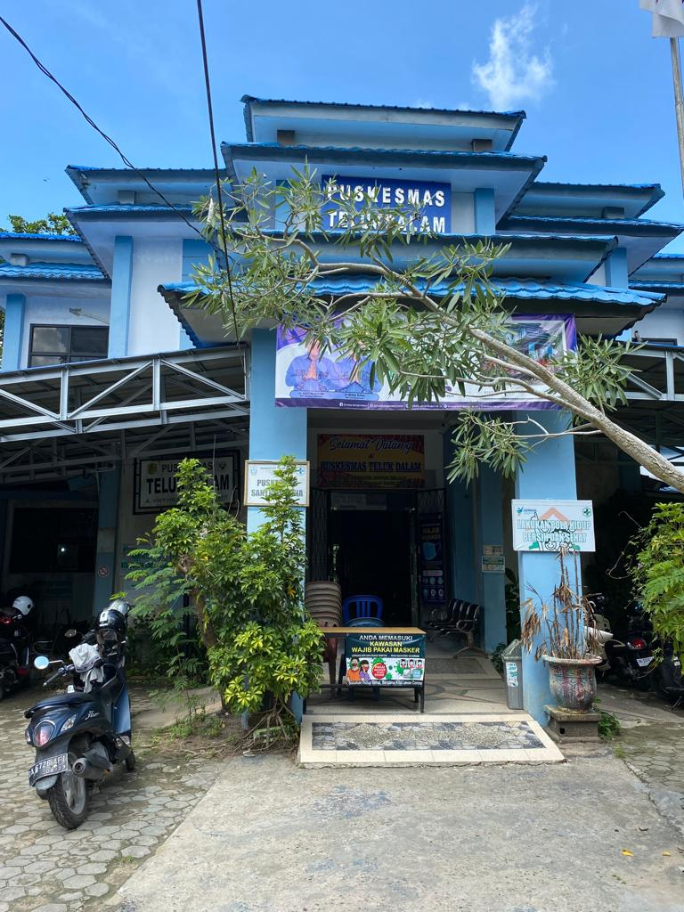

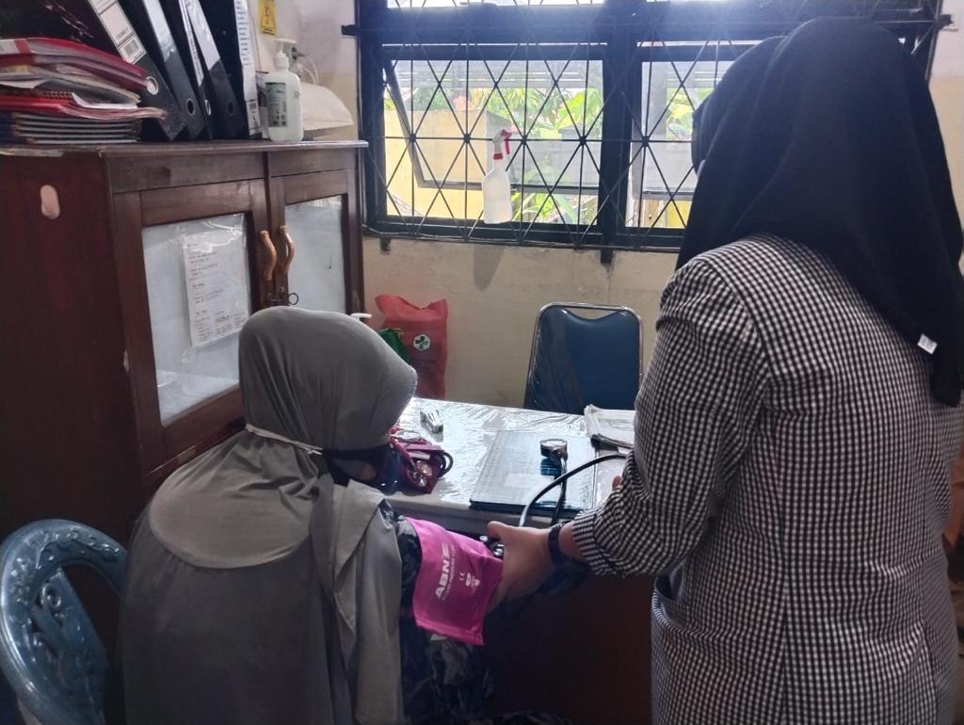 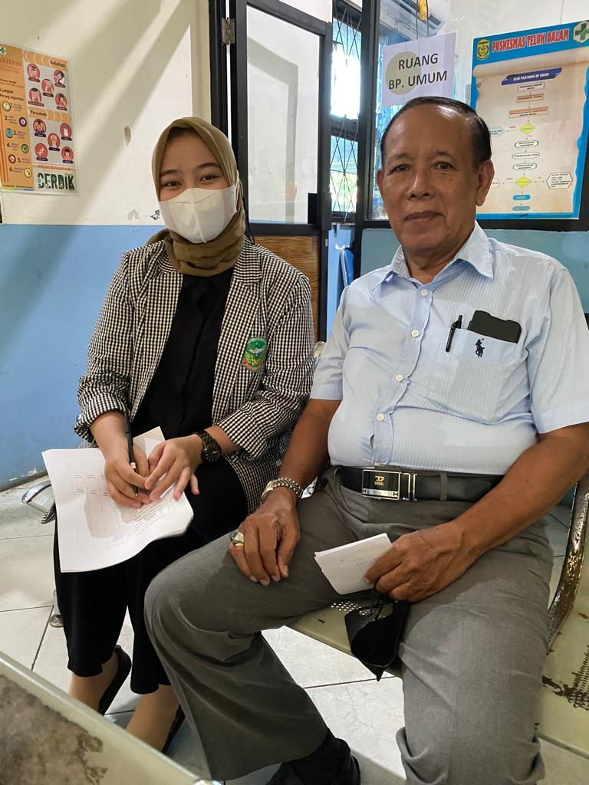

**Lampiran 10**

**Hasil Perhitungan SPSS Uji Validitas Dan Reabilitas**

|  |  |  |  |  |
| --- | --- | --- | --- | --- |
| **Correlations** | | | | |
|  | | P7 | P8 | TOTAL |
| P1 | Pearson Correlation | -.255 | .213 | .397* |
| Sig. (2-tailed) | .175 | .258 | .030 |
| N | 30 | 30 | 30 |
| P2 | Pearson Correlation | .270 | .409* | .511 |
| Sig. (2-tailed) | .149 | .025 | .077 |
| N | 30 | 30 | 30 |
| P3 | Pearson Correlation | .078 | .187 | .728** |
| Sig. (2-tailed) | .681 | .324 | .000 |
| N | 30 | 30 | 30 |
| P4 | Pearson Correlation | .048 | .413* | .569** |
| Sig. (2-tailed) | .801 | .023 | .001 |
| N | 30 | 30 | 30 |
| P5 | Pearson Correlation | .318 | .384* | .543** |
| Sig. (2-tailed) | .087 | .036 | .002 |
| N | 30 | 30 | 30 |
| P6 | Pearson Correlation | -.020 | .053 | .497** |
| Sig. (2-tailed) | .918 | .780 | .005 |
| N | 30 | 30 | 30 |
| P7 | Pearson Correlation | 1 | .121 | .593 |
| Sig. (2-tailed) |  | .524 | .548 |
| N | 30 | 30 | 30 |
| P8 | Pearson Correlation | .121 | 1 | .411** |
| Sig. (2-tailed) | .524 |  | .007 |
| N | 30 | 30 | 30 |
| TOTAL | Pearson Correlation | .114 | .480** | 1 |
| Sig. (2-tailed) | .548 | .007 |  |
| N | 30 | 30 | 30 |

|  |
| --- |
| *. Correlation is significant at the 0.05 level (2-tailed). |
| **. Correlation is significant at the 0.01 level (2-tailed). |

**Lampiran 11**

**Karateristik Responden dan 7 Komponen Kualitas Tidur**

Your temporary usage period for IBM SPSS Statistics will expire in 4551 days.

NEW FILE.

DATASET NAME DataSet1 WINDOW=FRONT. NEW FILE.

DATASET NAME DataSet2 WINDOW=FRONT. DATASET CLOSE DataSet1.

DATASET CLOSE DataSet0. FREQUENCIES VARIABLES=U JK PK TD

/ORDER=ANALYSIS.

# Frequencies

**Notes**

Output Created Comments

Input Active Dataset

Filter Weight Split File

N of Rows in Working Data

File

Missing Value Handling Definition of Missing

Cases Used

Syntax

Resources

Processor Time

Elapsed Time

16-JUL-2023 20:37:14

DataSet2

<none>

<none>

<none>

286

User-defined missing values are treated as missing.

Statistics are based on all cases with valid data.

FREQUENCIES VARIABLES=U JK PK TD

/ORDER=ANALYSIS.

00:00:00,02

00:00:00,48

**Statistics**

|  |  |  |  |  |  |
| --- | --- | --- | --- | --- | --- |
| Umur | | | Jenis Kelamin | Pekerjaan | Tekanan Darah |
| N | Valid | 286 | 286 | 286 | 286 |
| Missing | 0 | 0 | 0 | 0 |

# Frequency Table

**Umur**

|  |  |  |  |  |  |
| --- | --- | --- | --- | --- | --- |
| Frequency | | | Percent | Valid Percent | Cumulative Percent |
| Valid |  | 143 | 50.0 | 50.0 | 50.0 |
| 60-74 tahun | 96 | 33.6 | 33.6 | 83.6 |
| 75-90 tahun | 47 | 16.4 | 16.4 | 100.0 |
| Total | 286 | 100.0 | 100.0 |  |

**Jenis Kelamin**

|  |  |  |  |  |  |
| --- | --- | --- | --- | --- | --- |
| Frequency | | | Percent | Valid Percent | Cumulative Percent |
| Valid |  | 143 | 50.0 | 50.0 | 50.0 |
| Laki-laki | 82 | 28.7 | 28.7 | 78.7 |
| Perempuan | 61 | 21.3 | 21.3 | 100.0 |
| Total | 286 | 100.0 | 100.0 |  |

**Pekerjaan**

|  |  |  |  |  |  |
| --- | --- | --- | --- | --- | --- |
| Frequency | | | Percent | Valid Percent | Cumulative Percent |
| Valid |  | 143 | 50.0 | 50.0 | 50.0 |
| Irt | 51 | 17.8 | 17.8 | 67.8 |
| Pensiunan | 56 | 19.6 | 19.6 | 87.4 |
| Buruh | 8 | 2.8 | 2.8 | 90.2 |
| Pedagang | 14 | 4.9 | 4.9 | 95.1 |
| Tidak Bekerja | 14 | 4.9 | 4.9 | 100.0 |
| Total | 286 | 100.0 | 100.0 |  |

**Tekanan Darah**

|  |  |  |  |  |  |
| --- | --- | --- | --- | --- | --- |
| Frequency | | | Percent | Valid Percent | Cumulative Percent |
| Valid |  | 143 | 50.0 | 50.0 | 50.0 |
| Ringan = 140/90-159/99 mmHg | 51 | 17.8 | 17.8 | 67.8 |
| Sedang = 160/100-179/109 mmHg | 62 | 21.7 | 21.7 | 89.5 |
| Berat =180/110-209/119  mmHg | 30 | 10.5 | 10.5 | 100.0 |
| Total | 286 | 100.0 | 100.0 |  |

FREQUENCIES VARIABLES=P1 P2 P3 P4 P5 P6 P7

/ORDER=ANALYSIS.

# Frequencies

**Notes**

|  |  |  |
| --- | --- | --- |
| Output Created | | 16-JUL-2023 20:38:33 |
| Comments | |  |
| Input | Active Dataset | DataSet2 |
| Filter | <none> |
| Weight | <none> |
| Split File | <none> |
| N of Rows in Working Data File | 286 |
| Missing Value Handling | Definition of Missing | User-defined missing values are treated as missing. |
| Cases Used | Statistics are based on all cases with valid data. |
| Syntax | | FREQUENCIES VARIABLES=P1 P2 P3 P4 P5 P6 P7  /ORDER=ANALYSIS. |
| Resources | Processor Time | 00:00:00,02 |
| Elapsed Time | 00:00:00,06 |

**Statistics**

|  |  |  |  |  |  |  |
| --- | --- | --- | --- | --- | --- | --- |
| Kualitas Tidur Subyektif | | | Latensi Tidur | Durasi Tidur | Efisiensi Tidur | Gangguan Tidur |
| N | Valid | 286 | 286 | 286 | 286 | 286 |
| Missing | 0 | 0 | 0 | 0 | 0 |

**Statistics**

|  |  |  |  |
| --- | --- | --- | --- |
|  | | Penggunaan Obat Tidur | Disfungsi Disiang Hari |
| N | Valid | 286 | 286 |
| Missing | 0 | 0 |

# Frequency Table

**Kualitas Tidur Subyektif**

|  |  |  |  |  |  |
| --- | --- | --- | --- | --- | --- |
| Frequency | | | Percent | Valid Percent | Cumulative Percent |
| Valid |  | 143 | 50.0 | 50.0 | 50.0 |
| Sangat Baik | 1 | .3 | .3 | 50.3 |
| Cukup Baik | 142 | 49.7 | 49.7 | 100.0 |
| Total | 286 | 100.0 | 100.0 |  |

**Latensi Tidur**

|  |  |  |  |  |  |
| --- | --- | --- | --- | --- | --- |
| Frequency | | | Percent | Valid Percent | Cumulative Percent |
| Valid |  | 143 | 50.0 | 50.0 | 50.0 |
| 0 | 2 | .7 | .7 | 50.7 |
| 1-2 | 53 | 18.5 | 18.5 | 69.2 |
| 3-4 | 44 | 15.4 | 15.4 | 84.6 |
| 5-6 | 44 | 15.4 | 15.4 | 100.0 |
| Total | 286 | 100.0 | 100.0 |  |

**Durasi Tidur**

|  |  |  |  |  |  |
| --- | --- | --- | --- | --- | --- |
| Frequency | | | Percent | Valid Percent | Cumulative Percent |
| Valid |  | 143 | 50.0 | 50.0 | 50.0 |
| 5-6 jam | 36 | 12.6 | 12.6 | 62.6 |
| < 5 jam | 107 | 37.4 | 37.4 | 100.0 |
| Total | 286 | 100.0 | 100.0 |  |

**Efisiensi Tidur**

|  |  |  |  |  |  |
| --- | --- | --- | --- | --- | --- |
| Frequency | | | Percent | Valid Percent | Cumulative Percent |
| Valid |  | 143 | 50.0 | 50.0 | 50.0 |
| > 85% | 139 | 48.6 | 48.6 | 98.6 |
| 75-84% | 4 | 1.4 | 1.4 | 100.0 |
| Total | 286 | 100.0 | 100.0 |  |

**Gangguan Tidur**

|  |  |  |  |  |  |
| --- | --- | --- | --- | --- | --- |
| Frequency | | | Percent | Valid Percent | Cumulative Percent |
| Valid |  | 143 | 50.0 | 50.0 | 50.0 |
| 1x dalam seminggu | 15 | 5.2 | 5.2 | 55.2 |
| 2x dalam seminggu | 111 | 38.8 | 38.8 | 94.1 |
| > 3x dalam seminggu | 17 | 5.9 | 5.9 | 100.0 |
| Total | 286 | 100.0 | 100.0 |  |

**Penggunaan Obat Tidur**

|  |  |  |  |  |  |
| --- | --- | --- | --- | --- | --- |
| Frequency | | | Percent | Valid Percent | Cumulative Percent |
| Valid |  | 143 | 50.0 | 50.0 | 50.0 |
| Tidak pernah | 116 | 40.6 | 40.6 | 90.6 |
| 1x dalam seminggu | 22 | 7.7 | 7.7 | 98.3 |
| 2x dalam seminggu | 5 | 1.7 | 1.7 | 100.0 |
| Total | 286 | 100.0 | 100.0 |  |

**Disfungsi Disiang Hari**

|  |  |  |  |  |  |
| --- | --- | --- | --- | --- | --- |
| Frequency | | | Percent | Valid Percent | Cumulative Percent |
| Valid |  | 143 | 50.0 | 50.0 | 50.0 |
| 0 | 43 | 15.0 | 15.0 | 65.0 |
| 1-2 | 62 | 21.7 | 21.7 | 86.7 |
| 3-4 | 31 | 10.8 | 10.8 | 97.6 |
| 5-6 | 7 | 2.4 | 2.4 | 100.0 |
| Total | 286 | 100.0 | 100.0 |  |

**Lampiran 12**

**Hasil Statistik Kualitas Tidur**

Your temporary usage period for IBM SPSS Statistics will expire in 4550 days.

FREQUENCIES VARIABLES=KT

/ORDER=ANALYSIS.

Frequencies

# Notes

|  |  |  |
| --- | --- | --- |
| Output Created | | 17-JUL-2023 22:32:17 |
| Comments | |  |
| Input | Active Dataset | DataSet0 |
| Filter | <none> |
| Weight | <none> |
| Split File | <none> |
| N of Rows in Working Data File | 143 |
| Missing Value Handling | Definition of Missing | User-defined missing values are treated as missing. |
| Cases Used | Statistics are based on all cases with valid data. |
| Syntax | | FREQUENCIES VARIABLES=KT  /ORDER=ANALYSIS. |
| Resources | Processor Time | 00:00:00,02 |
| Elapsed Time | 00:00:00,08 |

[DataSet0]

# Statistics

Kualitas Tidur

N

Valid

Missing

143

0

# Kualitas Tidur

|  |  |  |  |  |  |
| --- | --- | --- | --- | --- | --- |
| Frequency | | | Percent | Valid Percent | Cumulative Percent |
| Valid | Baik | 1 | .7 | .7 | .7 |
| ringan | 28 | 19.6 | 19.6 | 20.3 |
| Sedang | 112 | 78.3 | 78.3 | 98.6 |
| Buruk | 2 | 1.4 | 1.4 | 100.0 |
| Total | 143 | 100.0 | 100.0 |  |

**Lampiran 12**

**Hubungan Kualitas Tidur Dengan Tekanan Darah**

NEW FILE.

DATASET NAME DataSet3 WINDOW=FRONT. NONPAR CORR

/VARIABLES=KT TD

/PRINT=SPEARMAN TWOTAIL NOSIG

/MISSING=PAIRWISE.

Nonparametric Correlations

# Notes

|  |  |  |
| --- | --- | --- |
| Output Created | | 16-JUL-2023 20:51:32 |
| Comments | |  |
| Input | Active Dataset | DataSet3 |
| Filter | <none> |
| Weight | <none> |
| Split File | <none> |
| N of Rows in Working Data File | 143 |
| Missing Value Handling | Definition of Missing | User-defined missing values are treated as missing. |
| Cases Used | Statistics for each pair of variables are based on all the cases with valid data for that pair. |
| Syntax | | NONPAR CORR  /VARIABLES=KT TD  /PRINT=SPEARMAN TWOTAIL NOSIG  /MISSING=PAIRWISE. |
| Resources | Processor Time | 00:00:00,00 |
| Elapsed Time | 00:00:00,47 |
| Number of Cases Allowed | 629145 casesa |

a. Based on availability of workspace memory

[DataSet3]

# Correlations

|  |  |  |  |  |
| --- | --- | --- | --- | --- |
| Kualitas Tidur | | | | Tekanan Darah |
| Spearman's rho | Kualitas Tidur | Correlation Coefficient | 1.000 | -.126 |
| Sig. (2-tailed) | . | .134 |
| N | 143 | 143 |
| Tekanan Darah | Correlation Coefficient | -.126 | 1.000 |
| Sig. (2-tailed) | .134 | . |
| N | 143 | 143 |

|  |  |  |  |  |  |  |  |  |  |  |  |  |  |  |  |  |
| --- | --- | --- | --- | --- | --- | --- | --- | --- | --- | --- | --- | --- | --- | --- | --- | --- |
|  | MASTER TABEL PENELITIAN HUBUNGAN KUALITAS TIDUR DENGAN KEJADIAN TEKANAN DARAH PADA LANSIA HIPERTENSI DI PUSKESMAS TELUK DALAM | | | | | | | | | | | | | | | |
|  |  |  |  |  |  |  | BANJARMASIN 2023 | | |  |  |  |  |  |  |  |
|  |  |  |  |  |  |  | Karakteristik Responden |  |  |  |  |  |  |  |  |  |
| No | Nama | Umur | Jenis Kelamin | Pekerjaan | Tekanan Darah | Kualitas Tidur Subyektif | Latensi Tidur | Durasi Tidur | Efisiensi Tidur | Gangguan Tidur | Penggunaan Obat Tidur | Disfungsi Disiang Hari | TOTAL | KATEGORI |  |  |
| 1 | J | 1 | 1 | 2 | 2 | 1 | 3 | 3 | 0 | 1 | 0 | 1 | 9 | Sedang |  |  |
| 2 | H | 2 | 2 | 1 | 1 | 1 | 2 | 3 | 0 | 2 | 0 | 3 | 11 | Sedang |  |  |
| 3 | S | 1 | 1 | 2 | 2 | 1 | 3 | 3 | 0 | 3 | 0 | 1 | 11 | Sedang |  |  |
| 4 | R | 1 | 2 | 1 | 3 | 1 | 3 | 3 | 0 | 2 | 0 | 1 | 10 | Sedang |  |  |
| 5 | M | 1 | 2 | 1 | 1 | 1 | 2 | 2 | 0 | 2 | 0 | 1 | 8 | Sedang |  |  |
| 6 | B | 1 | 1 | 2 | 2 | 1 | 3 | 3 | 0 | 3 | 1 | 1 | 12 | Sedang |  |  |
| 7 | M | 1 | 1 | 3 | 2 | 1 | 3 | 3 | 0 | 2 | 0 | 2 | 11 | Sedang |  |  |
| 8 | K | 1 | 2 | 1 | 1 | 1 | 3 | 3 | 0 | 3 | 0 | 1 | 11 | Sedang |  |  |
| 9 | N | 1 | 2 | 1 | 2 | 1 | 2 | 3 | 0 | 2 | 0 | 1 | 9 | Sedang |  |  |
| 10 | S | 1 | 1 | 3 | 2 | 1 | 3 | 3 | 0 | 2 | 0 | 1 | 10 | Sedang |  |  |
| 11 | R | 1 | 2 | 1 | 1 | 1 | 3 | 3 | 0 | 2 | 0 | 2 | 11 | Sedang |  |  |
| 12 | S | 2 | 1 | 2 | 1 | 1 | 1 | 3 | 0 | 2 | 0 | 1 | 8 | Sedang |  |  |
| 13 | H | 1 | 2 | 1 | 1 | 1 | 3 | 3 | 0 | 2 | 0 | 2 | 11 | Sedang |  |  |
| 14 | S | 2 | 2 | 1 | 1 | 1 | 3 | 3 | 0 | 3 | 0 | 2 | 12 | Sedang |  |  |
| 15 | K | 1 | 1 | 2 | 1 | 1 | 3 | 3 | 0 | 2 | 0 | 2 | 11 | Sedang |  |  |
| 16 | Y | 1 | 2 | 1 | 2 | 1 | 2 | 3 | 0 | 2 | 1 | 1 | 10 | Sedang |  |  |
| 17 | F | 1 | 2 | 1 | 1 | 1 | 2 | 3 | 0 | 2 | 0 | 2 | 10 | Sedang |  |  |
| 18 | D | 1 | 2 | 1 | 1 | 1 | 3 | 3 | 0 | 2 | 0 | 2 | 11 | Sedang |  |  |
| 19 | R | 1 | 1 | 2 | 2 | 1 | 0 | 3 | 0 | 2 | 0 | 2 | 8 | Sedang |  |  |
| 20 | R | 1 | 2 | 1 | 1 | 1 | 0 | 3 | 0 | 2 | 0 | 2 | 8 | Sedang |  |  |
| 21 | N | 1 | 2 | 1 | 1 | 1 | 3 | 2 | 0 | 3 | 1 | 1 | 11 | Sedang |  |  |
| 22 | I | 2 | 1 | 2 | 2 | 1 | 3 | 3 | 0 | 3 | 0 | 0 | 10 | Sedang |  |  |
| 23 | H | 1 | 2 | 1 | 1 | 1 | 3 | 3 | 0 | 2 | 0 | 1 | 10 | Sedang |  |  |
| 24 | K | 2 | 1 | 2 | 1 | 1 | 1 | 2 | 0 | 2 | 0 | 2 | 8 | Sedang |  |  |
| 25 | S | 1 | 2 | 2 | 1 | 1 | 3 | 2 | 0 | 2 | 1 | 2 | 11 | Sedang |  |  |
| 26 | M | 1 | 1 | 2 | 1 | 1 | 3 | 3 | 0 | 2 | 0 | 1 | 10 | Sedang |  |  |
| 27 | T | 1 | 1 | 2 | 2 | 1 | 1 | 2 | 0 | 3 | 0 | 1 | 8 | Sedang |  |  |
| 28 | S | 1 | 1 | 2 | 1 | 1 | 2 | 2 | 1 | 2 | 0 | 1 | 9 | Sedang |  |  |
| 29 | R | 1 | 1 | 2 | 1 | 1 | 1 | 3 | 1 | 3 | 0 | 2 | 11 | Sedang |  |  |
| 30 | Y | 1 | 1 | 2 | 1 | 1 | 3 | 3 | 0 | 3 | 0 | 1 | 11 | Sedang |  |  |
| 31 | U | 1 | 1 | 1 | 1 | 1 | 1 | 2 | 0 | 2 | 1 | 1 | 8 | Sedang |  |  |
| 32 | W | 1 | 1 | 2 | 2 | 1 | 1 | 2 | 0 | 2 | 0 | 0 | 6 | Ringan |  |  |
| 33 | O | 1 | 1 | 2 | 1 | 1 | 3 | 3 | 0 | 3 | 0 | 2 | 12 | Sedang |  |  |
| 34 | P | 1 | 1 | 2 | 1 | 1 | 1 | 2 | 0 | 2 | 0 | 1 | 7 | Ringan |  |  |
| 35 | U | 1 | 2 | 1 | 2 | 1 | 3 | 3 | 0 | 2 | 0 | 1 | 10 | Sedang |  |  |
| 36 | Y | 1 | 2 | 1 | 2 | 1 | 3 | 3 | 0 | 3 | 0 | 2 | 12 | Sedang |  |  |
| 37 | R | 2 | 2 | 1 | 2 | 1 | 1 | 3 | 0 | 2 | 0 | 3 | 10 | Sedang |  |  |
| 38 | F | 2 | 2 | 1 | 2 | 1 | 2 | 2 | 0 | 2 | 1 | 1 | 9 | Sedang |  |  |
| 39 | G | 1 | 2 | 1 | 1 | 1 | 1 | 3 | 0 | 2 | 1 | 1 | 9 | Sedang |  |  |
| 40 | K | 1 | 1 | 4 | 2 | 1 | 3 | 3 | 1 | 3 | 2 | 3 | 16 | Buruk |  |  |
| 41 | L | 2 | 1 | 4 | 2 | 1 | 3 | 3 | 0 | 2 | 0 | 1 | 10 | Sedang |  |  |
| 42 | E | 1 | 2 | 1 | 3 | 1 | 3 | 3 | 0 | 3 | 2 | 3 | 15 | buruk |  |  |
| 43 | D | 1 | 1 | 5 | 3 | 1 | 3 | 3 | 0 | 2 | 0 | 1 | 10 | Sedang |  |  |
| 44 | B | 2 | 1 | 2 | 3 | 1 | 2 | 3 | 0 | 2 | 0 | 2 | 10 | Sedang |  |  |
| 45 | M | 2 | 2 | 2 | 3 | 1 | 3 | 3 | 0 | 2 | 1 | 1 | 11 | Sedang |  |  |
| 46 | N | 1 | 1 | 1 | 1 | 1 | 1 | 3 | 0 | 2 | 0 | 2 | 9 | Sedang |  |  |
| 47 | M | 1 | 2 | 1 | 3 | 1 | 2 | 3 | 0 | 2 | 0 | 1 | 9 | Sedang |  |  |
| 48 | D | 2 | 1 | 2 | 1 | 1 | 1 | 3 | 0 | 2 | 1 | 2 | 10 | Sedang |  |  |
| 49 | S | 1 | 2 | 1 | 1 | 1 | 2 | 3 | 0 | 2 | 0 | 3 | 11 | Sedang |  |  |
| 50 | S | 2 | 1 | 2 | 2 | 1 | 3 | 3 | 0 | 2 | 1 | 3 | 13 | Sedang |  |  |
| 51 | S | 1 | 2 | 1 | 2 | 1 | 2 | 3 | 0 | 2 | 0 | 1 | 9 | Sedang |  |  |
| 52 | S | 2 | 1 | 5 | 3 | 1 | 1 | 3 | 0 | 2 | 0 | 2 | 9 | Sedang |  |  |
| 53 | A | 1 | 2 | 2 | 3 | 1 | 3 | 3 | 0 | 2 | 0 | 1 | 10 | Sedang |  |  |
| 54 | A | 2 | 1 | 3 | 3 | 1 | 3 | 3 | 0 | 2 | 0 | 0 | 9 | Sedang |  |  |
| 55 | R | 2 | 2 | 2 | 3 | 1 | 1 | 3 | 0 | 2 | 0 | 0 | 7 | Ringan |  |  |
| 56 | T | 2 | 1 | 5 | 3 | 1 | 2 | 3 | 0 | 2 | 0 | 0 | 8 | Sedang |  |  |
| 57 | S | 2 | 1 | 5 | 2 | 1 | 1 | 3 | 0 | 2 | 0 | 0 | 7 | Ringan |  |  |
| 58 | K | 2 | 1 | 5 | 2 | 1 | 1 | 3 | 0 | 2 | 1 | 0 | 8 | Sedang |  |  |
| 59 | L | 1 | 1 | 5 | 2 | 1 | 1 | 3 | 0 | 2 | 0 | 0 | 7 | Ringan |  |  |
| 60 | H | 1 | 1 | 2 | 2 | 1 | 1 | 3 | 0 | 2 | 0 | 0 | 7 | Ringan |  |  |
| 61 | G | 1 | 1 | 2 | 2 | 1 | 1 | 3 | 0 | 2 | 0 | 0 | 7 | Ringan |  |  |
| 61 | B | 2 | 2 | 2 | 1 | 1 | 1 | 3 | 0 | 2 | 0 | 0 | 7 | Ringan |  |  |
| 63 | N | 1 | 2 | 1 | 1 | 1 | 1 | 2 | 0 | 2 | 0 | 1 | 7 | Ringan |  |  |
| 64 | M | 2 | 2 | 1 | 1 | 1 | 2 | 2 | 0 | 2 | 1 | 1 | 9 | Sedang |  |  |
| 65 | M | 1 | 2 | 1 | 1 | 1 | 2 | 2 | 0 | 2 | 0 | 1 | 8 | Sedang |  |  |
| 66 | N | 2 | 2 | 1 | 1 | 1 | 2 | 3 | 0 | 2 | 0 | 1 | 9 | Sedang |  |  |
| 67 | F | 1 | 2 | 1 | 1 | 1 | 2 | 3 | 0 | 2 | 0 | 2 | 10 | Sedang |  |  |
| 68 | R | 2 | 2 | 1 | 1 | 1 | 1 | 3 | 0 | 2 | 0 | 2 | 9 | Sedang |  |  |
| 69 | T | 1 | 2 | 1 | 1 | 1 | 1 | 2 | 0 | 2 | 0 | 1 | 7 | Ringan |  |  |
| 70 | P | 2 | 1 | 2 | 1 | 1 | 2 | 2 | 0 | 2 | 0 | 1 | 8 | Sedang |  |  |
| 71 | L | 1 | 1 | 4 | 1 | 1 | 1 | 2 | 0 | 2 | 0 | 2 | 8 | Sedang |  |  |
| 72 | K | 2 | 1 | 5 | 3 | 1 | 2 | 3 | 0 | 2 | 1 | 1 | 10 | Sedang |  |  |
| 73 | S | 1 | 1 | 4 | 3 | 1 | 1 | 3 | 0 | 2 | 0 | 2 | 9 | Sedang |  |  |
| 74 | A | 1 | 1 | 4 | 3 | 1 | 1 | 3 | 0 | 2 | 0 | 0 | 7 | Ringan |  |  |
| 75 | H | 1 | 1 | 2 | 3 | 1 | 2 | 3 | 0 | 2 | 0 | 0 | 8 | Sedang |  |  |
| 76 | H | 1 | 1 | 2 | 3 | 1 | 2 | 3 | 0 | 2 | 2 | 2 | 12 | Sedang |  |  |
| 77 | N | 1 | 1 | 2 | 3 | 1 | 1 | 3 | 0 | 2 | 0 | 0 | 7 | Ringan |  |  |
| 78 | A | 1 | 1 | 2 | 2 | 1 | 1 | 3 | 0 | 3 | 0 | 0 | 8 | Sedang |  |  |
| 79 | A | 1 | 1 | 5 | 3 | 1 | 1 | 3 | 0 | 2 | 2 | 0 | 9 | Sedang |  |  |
| 80 | A | 1 | 1 | 5 | 2 | 1 | 1 | 2 | 0 | 2 | 0 | 0 | 6 | Ringan |  |  |
| 81 | I | 1 | 1 | 3 | 3 | 1 | 1 | 3 | 0 | 2 | 0 | 0 | 7 | Ringan |  |  |
| 82 | I | 1 | 1 | 3 | 1 | 1 | 1 | 2 | 0 | 2 | 0 | 0 | 6 | Ringan |  |  |
| 83 | K | 1 | 2 | 1 | 2 | 1 | 1 | 3 | 0 | 2 | 0 | 0 | 7 | Ringan |  |  |
| 84 | Y | 2 | 2 | 1 | 3 | 1 | 1 | 3 | 0 | 2 | 0 | 0 | 7 | Ringan |  |  |
| 85 | E | 2 | 2 | 1 | 3 | 1 | 1 | 3 | 0 | 2 | 0 | 0 | 7 | Ringan |  |  |
| 86 | E | 2 | 1 | 2 | 2 | 1 | 1 | 3 | 0 | 2 | 0 | 1 | 8 | Sedang |  |  |
| 87 | E | 1 | 2 | 2 | 3 | 1 | 1 | 3 | 0 | 2 | 1 | 1 | 9 | Sedang |  |  |
| 88 | T | 1 | 1 | 2 | 2 | 1 | 1 | 3 | 0 | 2 | 0 | 1 | 8 | Sedang |  |  |
| 89 | A | 1 | 2 | 1 | 3 | 1 | 1 | 3 | 0 | 2 | 0 | 1 | 8 | Sedang |  |  |
| 90 | A | 1 | 1 | 4 | 3 | 1 | 1 | 3 | 0 | 2 | 0 | 1 | 8 | Sedang |  |  |
| 91 | N | 1 | 2 | 1 | 3 | 1 | 1 | 3 | 0 | 2 | 0 | 2 | 9 | Sedang |  |  |
| 92 | N | 2 | 1 | 5 | 2 | 1 | 2 | 3 | 0 | 2 | 0 | 2 | 10 | Sedang |  |  |
| 93 | M | 1 | 2 | 2 | 2 | 1 | 2 | 3 | 0 | 2 | 2 | 1 | 11 | Sedang |  |  |
| 94 | L | 2 | 1 | 2 | 2 | 1 | 1 | 3 | 0 | 2 | 0 | 2 | 9 | Sedang |  |  |
| 95 | H | 1 | 2 | 2 | 2 | 1 | 1 | 3 | 0 | 2 | 0 | 1 | 8 | Sedang |  |  |
| 96 | G | 2 | 1 | 2 | 2 | 1 | 1 | 3 | 0 | 2 | 0 | 2 | 9 | Sedang |  |  |
| 97 | S | 2 | 1 | 5 | 2 | 1 | 1 | 3 | 0 | 2 | 0 | 1 | 8 | Sedang |  |  |
| 98 | S | 1 | 1 | 3 | 2 | 1 | 1 | 3 | 0 | 2 | 1 | 2 | 10 | Sedang |  |  |
| 99 | A | 2 | 1 | 2 | 2 | 1 | 1 | 2 | 0 | 1 | 0 | 0 | 5 | Baik |  |  |
| 100 | A | 2 | 1 | 2 | 2 | 1 | 1 | 2 | 0 | 2 | 0 | 0 | 6 | Ringan |  |  |
| 101 | E | 1 | 1 | 5 | 2 | 1 | 3 | 3 | 0 | 2 | 0 | 0 | 9 | Sedang |  |  |
| 102 | E | 1 | 2 | 1 | 2 | 1 | 3 | 3 | 0 | 1 | 0 | 0 | 8 | Sedang |  |  |
| 103 | M | 1 | 1 | 2 | 2 | 1 | 2 | 3 | 0 | 2 | 1 | 0 | 9 | Sedang |  |  |
| 104 | M | 1 | 2 | 2 | 2 | 1 | 1 | 3 | 0 | 1 | 0 | 0 | 6 | Ringan |  |  |
| 105 | N | 1 | 2 | 2 | 2 | 1 | 2 | 3 | 0 | 2 | 1 | 0 | 9 | Sedang |  |  |
| 106 | L | 1 | 1 | 2 | 2 | 1 | 1 | 3 | 0 | 2 | 0 | 0 | 7 | Ringan |  |  |
| 107 | L | 1 | 1 | 2 | 1 | 1 | 3 | 3 | 0 | 3 | 1 | 0 | 11 | Sedang |  |  |
| 108 | K | 1 | 2 | 1 | 1 | 1 | 3 | 3 | 0 | 3 | 1 | 0 | 11 | Sedang |  |  |
| 109 | E | 2 | 1 | 5 | 1 | 1 | 3 | 3 | 0 | 1 | 1 | 0 | 9 | Sedang |  |  |
| 110 | A | 2 | 2 | 2 | 1 | 1 | 3 | 3 | 0 | 2 | 1 | 0 | 10 | Sedang |  |  |
| 111 | S | 1 | 1 | 4 | 1 | 1 | 3 | 3 | 0 | 2 | 0 | 0 | 9 | Sedang |  |  |
| 112 | S | 2 | 2 | 1 | 2 | 1 | 1 | 3 | 0 | 2 | 0 | 0 | 7 | Ringan |  |  |
| 113 | F | 1 | 1 | 4 | 2 | 1 | 1 | 3 | 0 | 1 | 0 | 0 | 6 | Ringan |  |  |
| 114 | H | 2 | 2 | 1 | 2 | 1 | 2 | 3 | 0 | 1 | 0 | 1 | 8 | Sedang |  |  |
| 115 | H | 1 | 1 | 1 | 2 | 1 | 2 | 3 | 0 | 1 | 0 | 1 | 8 | Sedang |  |  |
| 116 | B | 2 | 1 | 2 | 3 | 1 | 2 | 3 | 0 | 1 | 0 | 1 | 8 | Sedang |  |  |
| 117 | N | 1 | 1 | 2 | 3 | 1 | 2 | 3 | 0 | 1 | 0 | 1 | 8 | Sedang |  |  |
| 118 | A | 2 | 1 | 5 | 3 | 1 | 2 | 2 | 0 | 2 | 0 | 1 | 8 | Sedang |  |  |
| 119 | A | 1 | 1 | 2 | 2 | 1 | 1 | 2 | 0 | 1 | 0 | 1 | 6 | Ringan |  |  |
| 120 | S | 2 | 2 | 2 | 2 | 1 | 1 | 2 | 0 | 1 | 0 | 3 | 8 | Sedang |  |  |
| 121 | M | 1 | 2 | 1 | 2 | 1 | 2 | 2 | 0 | 2 | 0 | 1 | 8 | Sedang |  |  |
| 122 | O | 2 | 2 | 1 | 2 | 1 | 2 | 2 | 0 | 2 | 0 | 0 | 7 | Ringan |  |  |
| 123 | P | 1 | 1 | 2 | 2 | 1 | 2 | 2 | 0 | 2 | 0 | 1 | 8 | Sedang |  |  |
| 124 | F | 1 | 1 | 1 | 1 | 1 | 2 | 2 | 0 | 3 | 0 | 1 | 9 | Sedang |  |  |
| 125 | F | 1 | 1 | 1 | 1 | 1 | 3 | 2 | 0 | 2 | 0 | 2 | 10 | Sedang |  |  |
| 126 | Y | 1 | 1 | 2 | 1 | 1 | 3 | 2 | 0 | 2 | 0 | 1 | 9 | Sedang |  |  |
| 127 | A | 1 | 2 | 4 | 2 | 1 | 3 | 2 | 0 | 2 | 0 | 2 | 10 | Sedang |  |  |
| 128 | A | 2 | 2 | 2 | 2 | 1 | 3 | 2 | 0 | 2 | 0 | 1 | 9 | Sedang |  |  |
| 129 | N | 2 | 2 | 2 | 1 | 1 | 3 | 2 | 0 | 2 | 0 | 2 | 10 | Sedang |  |  |
| 130 | N | 1 | 1 | 3 | 1 | 1 | 3 | 2 | 0 | 2 | 0 | 1 | 9 | Sedang |  |  |
| 131 | N | 1 | 1 | 3 | 2 | 1 | 2 | 2 | 0 | 1 | 0 | 1 | 7 | Ringan |  |  |
| 132 | N | 2 | 1 | 2 | 1 | 1 | 2 | 2 | 0 | 2 | 0 | 1 | 8 | Sedang |  |  |
| 133 | E | 1 | 1 | 4 | 2 | 1 | 2 | 2 | 0 | 2 | 0 | 0 | 7 | Ringan |  |  |
| 134 | D | 2 | 2 | 1 | 1 | 1 | 2 | 3 | 0 | 2 | 0 | 0 | 8 | Sedang |  |  |
| 135 | S | 1 | 2 | 1 | 2 | 1 | 2 | 3 | 0 | 2 | 0 | 0 | 8 | Sedang |  |  |
| 136 | S | 1 | 1 | 4 | 3 | 1 | 2 | 3 | 0 | 1 | 0 | 0 | 7 | Ringan |  |  |
| 137 | A | 1 | 1 | 4 | 3 | 1 | 2 | 3 | 1 | 2 | 0 | 0 | 9 | Sedang |  |  |
| 138 | Y | 2 | 1 | 2 | 2 | 1 | 2 | 3 | 0 | 2 | 1 | 1 | 10 | Sedang |  |  |
| 139 | F | 1 | 2 | 1 | 1 | 1 | 2 | 3 | 0 | 2 | 0 | 1 | 9 | Sedang |  |  |
| 140 | M | 1 | 1 | 4 | 2 | 1 | 2 | 3 | 0 | 1 | 0 | 1 | 8 | Sedang |  |  |
| 141 | F | 1 | 1 | 4 | 2 | 1 | 2 | 3 | 0 | 2 | 0 | 1 | 9 | Sedang |  |  |
| 142 | A | 1 | 2 | 1 | 1 | 1 | 3 | 3 | 0 | 2 | 0 | 1 | 10 | Sedang |  |  |
| 143 | E | 2 | 2 | 1 | 2 | 0 | 3 | 3 | 0 | 2 | 0 | 1 | 9 | Sedang |  |  |
|  |  |  |  |  |  | 142 | 273 | 393 | 4 | 288 | 32 | 145 |  |  |  |  |

**CODING**

|  |  |
| --- | --- |
| **Usia** | |
| **Kode/Skor** | **Keterangan** |
| 1 | 60-74 |
| 2 | 75-100 |

|  |  |
| --- | --- |
| **Jenis Kelamin** | |
| **Kode/Skor** | **Keterangan** |
| 1 | Laki-laki |
| 2 | Perempuan |

|  |  |
| --- | --- |
| **Pekerjaan** | |
| **Kode/Skor** | **Keterangan** |
| 1 | IRT |
| 2 | Pensiunan |
| 3 | Buruh |
| 4 | Pedagang |
| 5 | Tidak Bekerja |

|  |  |
| --- | --- |
| **Tekanan Darah** | |
| **Kode/Skor** | **Keterangan** |
| 1 | Ringan (140/90-159/99 mmHg) |
| 2 | Sedang (160/100-179/109 mmHg) |
| 3 | Berat (180/110-209/119 mmHg) |